**Wport-W20**

**Embedded WiFi Module User Manual**

**V1.0**

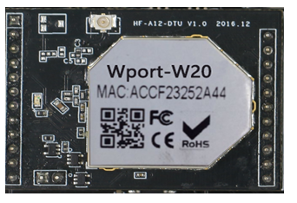

**Overview of Characteristic**

* **MIPS MCU with 4MB Flash and 8MB SRAM. Run on eCos**
* **Support TCP/IP/Telnet /Modbus TCP Protocol**
* **Support UART to Ethernet/Wi-Fi Conversion, Serial Speed Upto 230400 bps**
* **Support STA/AP/AP+STA Mode**
* **Support Router or Bridge Network Working Mode.**
* **Support 10/100M Ethernet Auto-Negotiation**
* **Support Easy Configuration Through a Web Interface or PC IOTService Tool**
* **Support Security Protocol Such As** **SSL/AES/DES3**
* **Support Web OTA Wirelss Upgrade**
* **Single +3.3V Power Supply**
* **Small Size: 25 x 40mm**

Table Of Contents

1. Product Overview 4

1.1. General Specification 4

1.2. Hardware Introduction 5

1.2.1. Pins Definition 5

1.2.2. Mechanical Size 6

1.2.3. On-board Chip Antenna 7

1.2.4. External Antenna 8

1.2.5. Order Information 10

1.3. Hardware Reference Design 10

1.3.1. Hardware Typical Application 10

1.4. Module Usage 11

**List Of Figures**

Figure 1. Wport-W20 5

Figure 2. WPORT-W20 Pins Map 5

Figure 3. WPORT-W20 Mechanical Dimension 7

Figure 4. WPORT-W20 Chip Antenna Keep Out Region 7

Figure 5. Suggested Module Placement Region 8

Figure 6. Exchange Resistor between Internal and External Antenna 9

Figure 7. WPORT-W20 Order Information 10

Figure 8. WPORT-W20 Hardware Typical Application 10

Figure 9. LED&BUTTON Reference 11

Figure 10. Ethernet Reference 11

**List Of tables**

Table 1 WPORT-W20 Module Technical Specifications 4

Table 2 WPORT-W20 Pins Definition 5

Table 3 WPORT-W20 External Antenna Parameters 8

**History**

**Ed. V1.0** Created on 11-17-2017.  
**Ed. V1.1** 08-29-2019 Update size

# Product Overview

## General Specification

Table 1 WPORT-W20 Module Technical Specifications

|  |  |  |
| --- | --- | --- |
| **Class** | **Item** | **Parameters** |
| **Wireless Parameters** | Wireless standard | 802.11 b/g/n |
| Frequency range | 2.412GHz-2.484GHz |
| Transmit Power | 802.11b: +20 dBm (Max.) |
| 802.11g: +18 dBm (Max.) |
| 802.11n: +15 dBm (Max.) |
| Receiver Sensitivity | 802.11b: -89 dBm |
| 802.11g: -81dBm |
| 802.11n: -71dBm |
| Antenna Option | External:I-PEX Connector |
| Internal:On-board chip antenna |
| **Hardware**  **Parameters** | Data Interface | UART: 1200bps - 230400bps |
| GPIO |
| Ethernet: 100Mpbs |
| Operating Voltage | 3.3V (+/-5%) |
| Operating Current | 170mA~300mA |
| Operating Temperature | -40℃- 85℃ |
| Storage Temperature | -45℃- 125℃ |
| Dimensions and Size | 45 x 32 x 8（mm） |
| **Software Parameters** | Network Type | STA/AP/AP+STA |
| Security Mechanisms | WEP/WPA-PSK/WPA2-PSK/WAPI |
| Encryption | WEP64/WEP128/TKIP/AES |
| Work Mode | Transparent Transmission and CMD |
| Serial command | AT+instruction set |
| Network Protocol | TCP/UDP/ARP/ICMP/DHCP/DNS/HTTP |
| Max. TCP Connection | 32 |
| User Configuration | Web Server＋AT command config. |
| User Application SW | Support customized application SW  Provide SDK package  Provide smart link tools |

## Hardware Introduction



1. Wport-W20

### Pins Definition

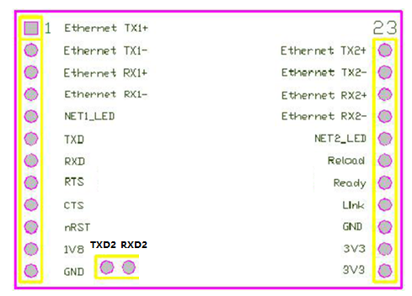

1. WPORT-W20 Pins Map

Table 2 WPORT-W20 Pins Definition

|  |  |  |  |  |
| --- | --- | --- | --- | --- |
| **Pin** | **Description** | **Name** | **Direction** | **Note** |
| **1** | Ethernet TX1+ | TX1+ | O | 1.8V voltage. Support transformer or PHY-PHY connection |
| **2** | Ethernet TX1- | TX1- | **O** |
| **3** | Ethernet RX1+ | RX1+ | **I** |
| **4** | Ethernet RX1- | RX1- | **I** |
| **5** | Ethernet 1 LED | NET1_LED | **I** |  |
| **6** | UART_TXD | UART_TXD | O |  |
| **7** | UART_RXD | UART_RXD | I |  |
| **8** | UART_RTS | UART_RTS | O |  |
| **9** | UART_CTS | UART_CTS | I |  |
| **10** | RESET | RESET | I | Effective low reset, >300ms |
| **11** | Output 1.8V | 1.8V | O | [1.8V@300mA](mailto:1.8V@300mA) for Ethernet |
| **12** | GND | GND | Power |  |
| **13/14** | VCC | 3.3V | Power | 3.3V@350mA |
| **15** | GND | GND | Power |  |
| **16** | WiFi status Indication | nLink | O | “1”- WIFI connection available, “0”- No WIFI connection  Can be configured as GPIO. |
| **17** | Indicate the module status of power on process | nReady | O | “0” or “Palmodic Signal” - Finish module boot up process;  “1” - Module boot up not finish.  Can be configured as GPIO. |
| **18** | Restore configuration | nReload | I | Module will Restore factory default configuration after set this pin “0” more than 3s, then set “1”. |
| **19** | Ethernet 2 LED | NET2_LED | I/O |  |
| **20** | Ethernet RX2- | RX2- | I | 1.8V voltage. Support transformer or PHY-PHY connection |
| **21** | Ethernet RX2+ | RX2+ | I |
| **22** | Ethernet TX2- | TX2- | O |
| **23** | Ethernet TX2+ | TX2+ | O |
| **24** | TXD2 | TXD2 | O |  |
| **25** | RXD2 | RXD2 | I |  |

### Mechanical Size

WPORT-W20 modules physical size as follows:

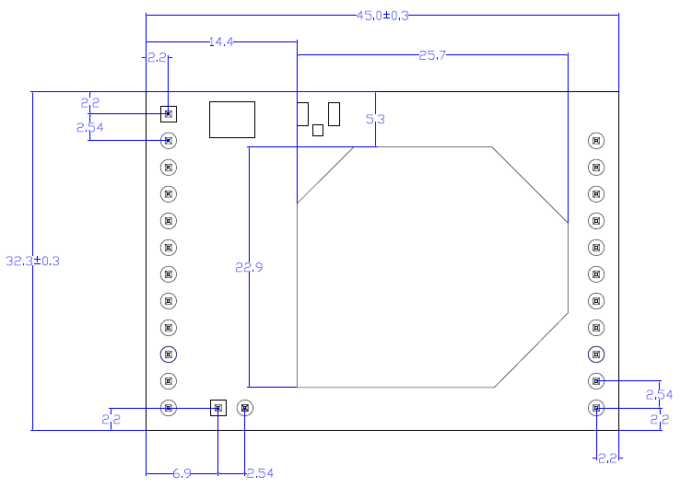

1. WPORT-W20 Mechanical Dimension

### On-board Chip Antenna

WPORT-W20 module supports internal on-board chip antenna option. When costomer select internal antenna, you shall comply with following antenna design rules and module location suggestions:

* For customer PCB, RED color region (6x8mm) can’t put componet or paste GND net;
* Antenna must be away from metal or high components at least 10mm;
* Antenna can’t be shielded by any metal enclosure; All cover, including plastic, shall be away from antenna at least 10mm;

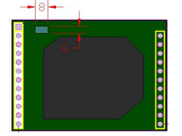

1. WPORT-W20 Chip Antenna Keep Out Region

High-Flying suggests WPORT-W20 module better locate in following region at customer board, which is to reduce the effect to antenna and wireless signal. And it is better to consult High-Flying technical engineer when you structure your module placement and PCB layout.

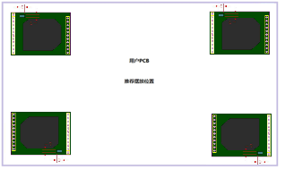

1. Suggested Module Placement Region

### External Antenna

Wport-W10 modules support internal antenna and external antenna option for user dedicated application. If user select external antenna, Wport-W10 modules must be connected to the 2.4G antenna according to IEEE 802.11b/g/n standards.

The antenna parameters required as follows:

Table 3 WPORT-W20 External Antenna Parameters

|  |  |
| --- | --- |
| **Item** | **Parameters** |
| Frequency range | 2.4~2.5GHz |
| Impedance | 50 Ohm |
| VSWR | 2 (Max) |
| Return Loss | -10dB (Max) |
| Connector Type | I-PEX or populate directly |

As the figure shown,in the normal situation, the red area is to exchange resistor.If needs external antenna,please replace the resistor from the red to the blue.

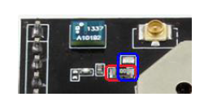

1. Exchange Resistor between Internal and External Antenna

### Order Information

Base on customer detailed requirement, WPORT-W20 series modules provide different variants and physical type for detailed application.

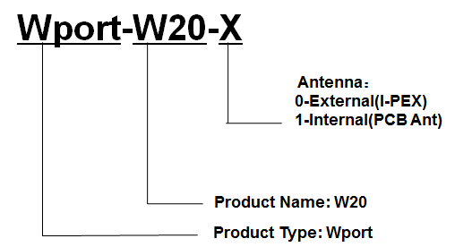

1. WPORT-W20 Order Information

## Hardware Reference Design

### Hardware Typical Application

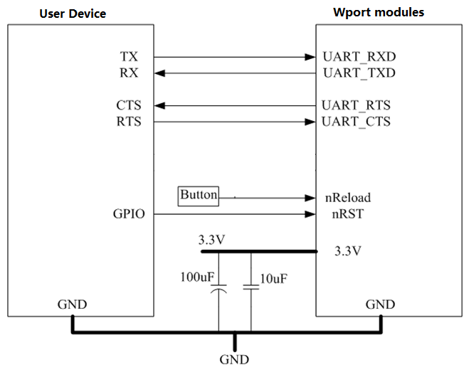

1. WPORT-W20 Hardware Typical Application

**Notes：**

**nRST-** Module hardware reset signal. Input. Logics “0” effective.

There is 100K Ohm pull-up resister internal. When module power up or some issue happened, MCU need assert nRST signal “0” at least 300ms, then set” 1” to keep module fully reset.

**nLink-** Module WIFI connection indication. Output.

There is 4.7K Ohm pull-up resister internal. When module connect to AP (STA mode) or some WiFi STA connect to module (AP mode), the module will output “0”. This signal is used to judge if module already at WiFi connection status.

**nReload**- Module restore to factory default configuration.Input. Logics “0” effective.

User can assert nReload signal “0” more than 3’s through button or MCU pin, then release, module will restore to factory default configuration and re-start boot up process. **User need add 4.7K~10K Ohm pull-up resister external the module.**

**UART_TXD/RXD**- UART port data transmit and receive signal.

There is 1K Ohm pull-down resister internal. User can’t add pull-up resister at these pins.

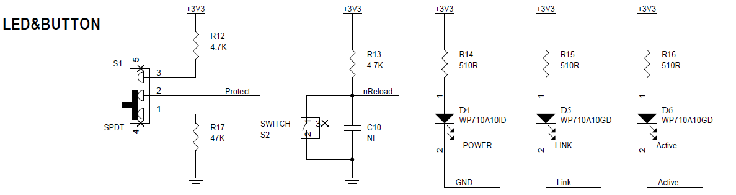

1. LED&BUTTON Reference

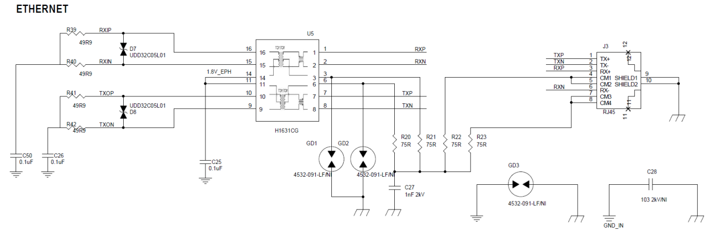

1. Ethernet Reference

## Module Usage

This module is used in HF2221, see HF2221 manual for detailed usage.