**Protoss-PG11**

**RS485 to GPRS**

**User Manual**

**V 1.0**

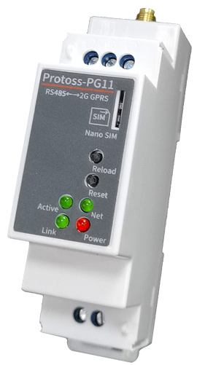

**Overview of Characteristic**

* Support Four Frequency Bands, Global Standard (850/900/1800/1900M Hz)
* Support GSM/GPRS and CMCC or CUCC SIM Card
* Support RS485 to GPRS Data Transmission, Serial Port Speed Up to 460800bps
* Supports Max 3 Channel TCP/UDP connections, Each Connection Supports 1400 Bytes of Data Cache, and the Network Channel Can be Bound to the Serial Port.
* Support Multiple Working Modes: Network Transparent Transmission Mode, HTTP Mode, MQTT, WebSocket
* Support IOTService Tool, Remotely and Dynamically Modify Module Parameters
* Support SMS AT Command Configuration
* Supports Registration Packet , Heartbeat Packet Function, and the Registration Package Supports ICCID, IMEI, IMSI, Software Version number, GPRS Connection Status and other Combinations.
* Support NTP
* Support Modbus TCP to RTU, Modbus Master Function
* Support IOTBridge for Remote Control and Config.
* Support IOTBridge working time, for example only works from 10:00 to 10:30 to save the data flow charge.
* Support Serial Port, Network OTA Upgrade Firmware.
* Multiple Type of Different Power Input：
* Protoss-PG11-H：100～240VAC@50～60Hz
* Protoss-PG11-M：9～48VDC@1A
* Size: 102.03 x 64.95 x 27.50 mm (L x W x H) ，C45 rail installation

# Table of contents

Table of contents 3

list of figures 4

list of tables 4

1. Product OVERVIEw 5

1.1. General Description 5

1.2. Device Parameters 5

1.3. Key Applications 6

2. hardware introduction 7

2.1. APPEARANCE 7

2.2. Interface Definition 8

2.3. RS485 Interface 9

2.4. Mechanical Size 9

2.5. Product Installation 11

2.6. Product Order Information 12

3. Function DESCRIPTION 13

APPENDIX A: CONTACT INFORMATION 14

list of figures

Figure 1. Protoss-PG11 Appearance 7

Figure 2. Protoss-PG11 Interface 8

Figure 3. Protoss-PG11 Mechanical Size 11

Figure 4. C45 Rail Installation 11

Figure 5. Protoss-PG11 Product Order Information 12

list of tables

Table1. Protoss-PG11 Technical Specifications 5

Table2. Protoss-PG11-H Interface Definition 8

Table3. Protoss-PG11-H Interface Definition 9

**HISTORY**

**Ed. V1.0**  02-12-2018 First version

# Product OVERVIEw

## General Description

The Protoss-PG11 can meet almost all M2M needs, including automotive and personal tracking services, wireless POS machines, smart metering, industrial PDAs, shared bikes, shared cars and more.

## Device Parameters

1. Protoss-PG11 Technical Specifications

|  |  |
| --- | --- |
| **Item** | **Parameter** |
| **Wireless Parameter** | |
| GPRS Band | GSM850, EGSM900, DCS1800, PCS1900 |
| GPRS Transmit Power | GSM850/EGSM900: 5dbm～32.5dbm  DCS1800/PCS1900: 0dbm～29.5dbm |
| GPRS Receiving Sensitivity | <-108.5dBm |
| GPRS Connection Features | GPRS Multi-Slot Level is 10 (default)  GPRS Mobile Station Level B |
| GPRS Date Features | GPRS Data Downlink Transmission: Up to 85.6 kbps  GPRS Data Uplink Transmission: Up to 85.6 kbps  Encoding Format: CS-1, CS-2, CS-3 and CS-4 |
| GPRS Antenna Interface Characteristic Impedance | 50Ω |
| **Serial Port** | |
| Port Number | 1 |
| Interface Standard | RS485 |
| Data Bits | 7, 8 |
| Stop Bits | 1, 2 |
| Check Bit | None，Even，Odd |
| Baud Rate | TTL：1200 bps~460800 bps， |
| Flow Control | No Flow Control  Half Flow Control(RS485) |
| **Software** | |
| Configuration | Serial AT Command  IOTService Serial Port Configuration Software  IOTService Network Configuration Software |
| Firmware Upgrade | Serial Port or OTA Upgrade |
| **Basic Parameter** | |
| SIM Card Interface | Support Nano-SIM Card: 1.8V, 3V |
| Working Temp | -40°C～85°C |
| Storage Temp | -45°C～90°C |
| Input Voltage | Protoss-PG11-H：100～240VAC@50～60Hz  Protoss-PG11-M：9～48VDC@1A |
| Start 20s Average Current | 61mA |
| Networked Standby Average Current | 22mA |
| 100 bytes/10 Seconds to Send Data Average Current | 57mA |
| 100 bytes/5 Seconds to Send Data Average Current | 91mA |
| 100 bytes/2 Seconds to Send Data Average Current | 233mA |
| Peak Current | 2A |
| Size | 102.03 x 64.95 x 27.50 mm |

## Key Applications

The Protoss-PG11 module connects the serial device to the Internet and conforms to the TCP/IP protocol for transmitting serial data.

* Remote device monitoring
* Production asset tracking and monitoring
* Security field
* Industrial sensors and controllers
* Health medical equipment
* ATM equipment
* Data acquisition equipment
* UPS power management equipment
* Telecommunication equipment
* Data display device
* Hand-held device
* Attendance system and terminal equipment

# hardware introduction

Protoss-PG11 is a GPRS solution for serial device networking. Data transmission via GPRS makes product integration very easy.

## APPEARANCE

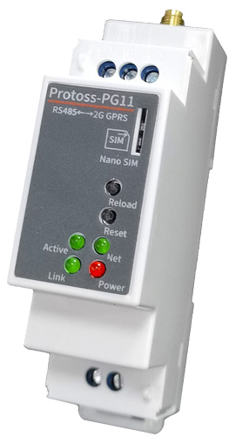 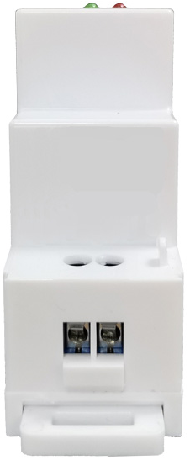 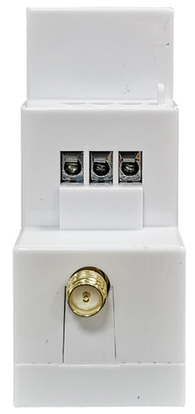 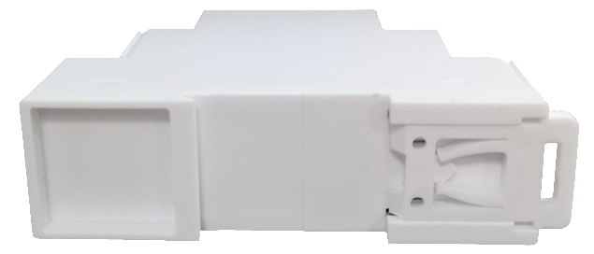

1. Protoss-PG11 Appearance

## Interface Definition

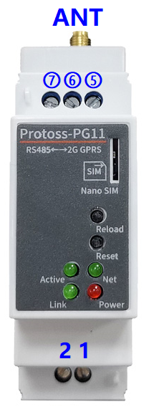

1. Protoss-PG11 Interface
2. Protoss-PG11-H Interface Definition

| **Pin** | **Description** | **Net Name** | **Signal Type** | **Comment** |
| --- | --- | --- | --- | --- |
| 1 | AC Power Input | L | Power | 100～240VAC Input |
| 2 | AC Power Input | N | Power |
| 5 |  | RS485_B- | IO | RS485 B- |
| 6 |  | RS485_A+ | IO | RS485 A+ |
| 7 | Signal GND | GND | Power | Used for RS485 GND, usually leave it unconnected |
| ANT | Antenna | ANT |  | GPRS SMA Antenna |
| SIM | SIM Slot | Nano SIM |  |  |
| Reload | Restore to factory setting button | Reload | I | **Detailed functions see <Notes>** |
| Reset | Reset button | Reset | I | Hardware reset button |
| Net | Network status LED | Net | O | Boot On: Bootup is OK.  2s Off -> 2s On: GPRS Register is OK.  0.1s Off -> 0.1s On: GPRS data is transferring. |
| Active | UART Data Transfer | Active | O | Off: No data transfer  0.3s Off -> 0.9s On: UART TX Output  0.3s Off -> 0.3s On: UART RX Receive  On: UART bidirection. |
| Power | Power LED | Power | O | On: Power input OK  Off: Power input NG. |
| Link | Server connection LED | Link | O | On: SOCK A connection OK.  Off: no Socket A connection. |

1. Protoss-PG11-H Interface Definition

| **Pin** | **Description** | **Net Name** | **Signal Type** | **Comment** |
| --- | --- | --- | --- | --- |
| 1 | DC Power Input | VCC+ | Power | 9～48VDC@1A Input |
| 2 | DC Power Input | GND- | Power |
| 5 |  | RS485_B- | IO | RS485 B- |
| 6 |  | RS485_A+ | IO | RS485 A+ |
| 7 | Signal GND | GND | Power | Used for RS485 GND, usually leave it unconnected |
| ANT | Antenna | ANT |  | GPRS SMA Antenna |
| SIM | SIM Slot | Nano SIM |  |  |
| Reload | Restore to factory setting button | Reload | I | **Detailed functions see <Notes>** |
| Reset | Reset button | Reset | I | Hardware reset button |
| Net | Network status LED | Net | O | Boot On: Bootup is OK.  2s Off -> 2s On: GPRS Register is OK.  0.1s Off -> 0.1s On: GPRS data is transferring. |
| Active | UART Data Transfer | Active | O | Off: No data transfer  0.3s Off -> 0.9s On: UART TX Output  0.3s Off -> 0.3s On: UART RX Receive  On: UART bidirection. |
| Power | Power LED | Power | O | On: Power input OK  Off: Power input NG. |
| Link | Server connection LED | Link | O | On: SOCK A connection OK.  Off: no Socket A connection. |

**<Notes>:**

**I — Input; O — Output; Power—Power Supply**

**nReload Pin (Button) function:**

1. **After module is powered up, long press this button (“Low” > 3s) and loose to make the module recover to factory setting.**

## RS485 Interface

RS485 use two wire links, A(DATA+), B(DATA-). Connect A(+) to A(+), B(-) to B(-) for communication. Suggest to connect GND together when interference is very severe.

The RS485 interface support maximum 32 485 device, device. The cable maximum length is 1200 meters. Need to add 120Ohm terminal resistor for over 300 meters.

## Mechanical Size

The dimensions of Protoss-PG11 are defined as following pictures(mm):

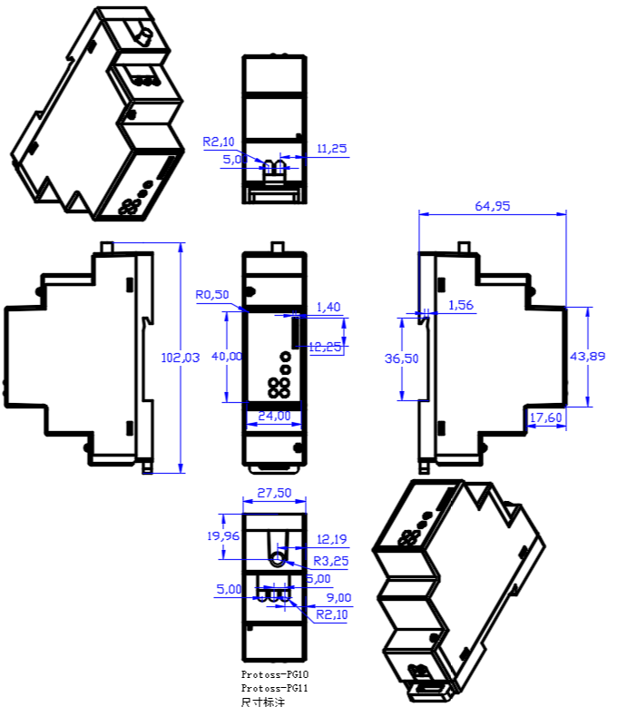

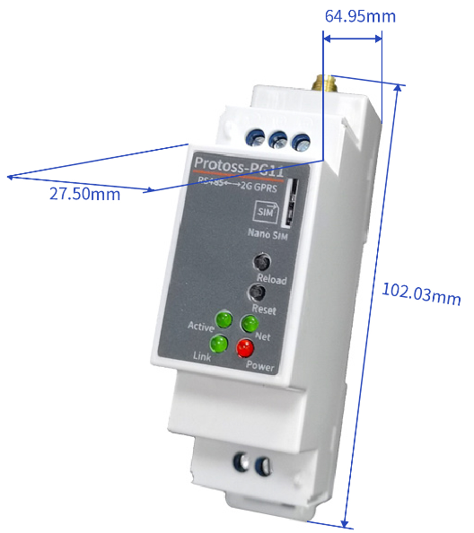

1. Protoss-PG11 Mechanical Size

## Product Installation

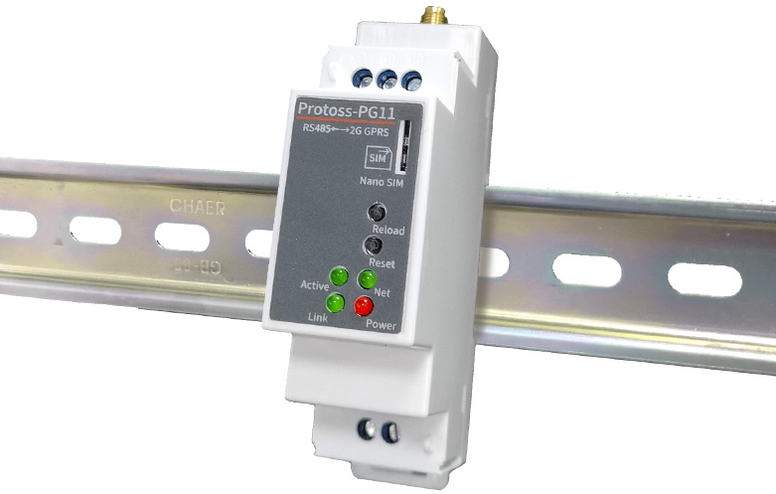

1. C45 Rail Installation

## Product Order Information

Based on customers detailed requirements, we provide different configuration Protoss-PG11, details as below:

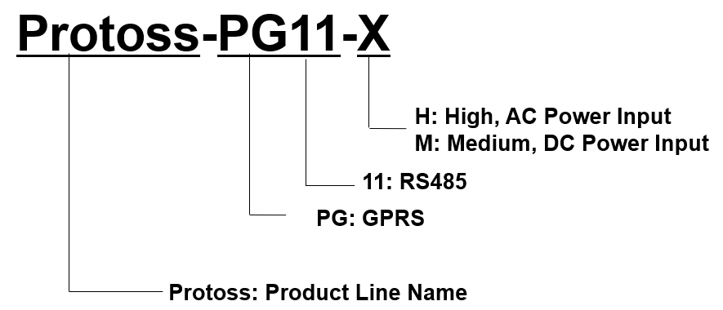

1. Protoss-PG11 Product Order Information

# 

# Function DESCRIPTION

Refer to “4G_2G_NB DTU Products Functions” document for more detailed function.

# APPENDIX A: CONTACT INFORMATION

**------------------------------------------------------------------------------------------------------------**

**Address:** Room1002 , #1Building, No.3000 Longdong Avenue, Pudong District, Shanghai, China   201202

**Website:** [www.iotworkshop.com](http://www.iotworkshop.com) or [www.hi-flying.com](http://www.hi-flying.com)

**Contact:**

Sales：[sales@iotworkshop.com](mailto://sales@iotworkshop.com)

Support：[support@iotworkshop.com](mailto://support@iotworkshop.com)

Service：[service@iotworkshop.com](mailto://service@iotworkshop.com)

Business：[business@iotworkshop.com](mailto://business@iotworkshop.com)

**---------------------------------------------------------------------------- -------------------------------**

**For more information about us, please visit our website: www.iotworkshop.com**

**< END OF DOCUMENT >**