**Protoss-PE11**

**RS485 to Ethernet**

**User Manual**

**V 1.0**

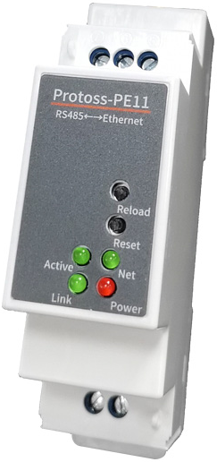

**Overview of Characteristic**

* **Cortex-M3 MCU with 2MB Flash and 128KB SRAM**
* **Use FreeRTOS Operation System**
* **Support TCP/UDP/MQTT/HTTP/WebSocket Protocol**
* **Support Modbus TCP to RTU, Modbus Master Function**
* **Support RS485 To 10/100M Ethernet Conversion, Serial Speed Up to 460800 bps**
* **Support 10/100M Ethernet Auto-Negotiation**
* **Support Webpage Easy Configuration or PC IOTService Tool**
* **Support Security Protocol Such As** **AES/DES3**
* **Support Heartbeat and Resister Packet Function**
* **Support Webpage OTA Wireless Upgrade**
* **Support Industrial Temperature: -40 to +85˚ C**
* **Multiple Type of Different Power Input：**
  + **Protoss-PE11-H：100～240VAC@50～60Hz**
  + **Protoss-PE11-M：9～48VDC@1A**
* **Size: 97.60 x 64.95 x 27.50 mm (L x W x H) ，C45 rail installation**

# Table Of Contents Table Of Contents

Table Of Contents Table Of Contents 3

List Of Figures 4

List Of Tables 5

History 5

1. Product Overview 6

1.1. General Description 6

1.2. Device Paremeters 6

1.3. Key Application 7

2. Hardware Introduction 8

2.1. Protoss-PE11 Pins Definition 9

2.2. RS485 Interface 10

2.3. RJ45 Interface 10

2.4. Mechanical Size 11

2.5. Product Installation 13

2.6. Order Information 13

3. Function DESCRIPTION 14

Appendix A: Contact Information 15

List Of Figures

Figure 1. Protoss-PE11 Appearance 8

Figure 2. Protoss-PE11 Interface 9

Figure 3. RJ45 Pin Defination 10

Figure 4. Protoss-PE11 Mechanical Dimension 12

Figure 5. Product Installation 13

Figure 6. Protoss-PE11 Product Order Information 13

List Of Tables

Table1. Protoss-PE11 Technical Specifications 6

Table2. Protoss-PE11-H Interface Definition 9

Table3. Protoss-PE11-M Interface Definition 10

Table4. RJ45 Interface 11

History

**Ed. V1.0**  02-10-2020 First Version

# Product Overview

## General Description

The Protoss-PE11 provides a RS485 interface to TCP/IP data transfer product. The Protoss-PE11 integrate TCP/IP controller, memory, 10/100M Ethernet transceiver, RS485 and integrates a fully developed TCP/IP network stack and FreeRTOS OS. Protoss-PE11 also includes an embedded web server used to configure device.

The Protoss-PE11 using highly integrated hardware and software platform, it has been optimized for all kinds of applications in the industrial control, smart grid, personal medical application and remote control that have lower data rates, and transmit or receive data on an infrequent basis.

## Device Paremeters

1. Protoss-PE11 Technical Specifications

|  |  |
| --- | --- |
| **Item** | **Parameters** |
| **System Information** | |
| Processor/Frequency | Cortex-M3/96MHz |
| Flash/SDRAM | 2MB/128KB |
| Operating System | FreeRTOS |
| **Ethernet Port** | |
| Port Number | 1 |
| Interface Standard | 10/100 Base-T Auto-Negotiation |
| Transformer | Integrated |
| Network Protocol | IP，TCP，UDP，DHCP，DNS，HTTP Server/Client，ARP, AutoIP, ICMP， Telnet, NTP, Modbus TCP |
| Security Protocol | AES 128Bit  DES3 |
| **Serial Port** | |
| Port Number | 1 RS485 |
| Data Bits | 5,6,7,8 |
| Stop Bit | 1,2 |
| Check Bit | None, Even, Odd |
| Baud Rate | TTL: 600 bps~460800 bps |
| Flow Control | No Flow Control  Software Xon/ Xoff flow control |
| **Software** | |
| Web Pages | Http Web Configuration  Customization of HTTP Web Pages |
| Configuration | Web  CLI  XML import  Telnet  IOTService PC Software  UART Fast Config |
| Firmware Upgrade | Webpage, IOTService Tools |
| **Basic Parameter** | |
| Size | 97.60mm x 64.95mm x 27.50mm |
| Operating Temp. | -40 ~ 85°C |
| Storage Temp. | -45 ~ 105°C, 5 ~ 95% RH（no condensation） |
| Input Voltage | Protoss-PE11-H：100～240VAC@50～60Hz  Protoss-PE11-M：9～48VDC@1A |
| Working Current | ~100mA |
| Power | <400mW |

## Key Application

The Protoss-PE11 device connects serial device to Ethernet networks using the TCP/IP protocol:

* Remote equipment monitoring
* Asset tracking and telemetry
* Security Application
* Industrial sensors and controls
* Medical devices
* ATM machines
* Data collection devices
* Universal Power Supply (UPS) management units
* Telecommunications equipment
* Data display devices
* Handheld instruments
* Modems
* Time/attendance clocks and terminals

# Hardware Introduction

The Protoss-PE11 unit is a complete solution for serial port device connecting to network. This powerful device supports a 10/100BASE-T Ethernet connection, a reliable and proven operating system stored in flash memory, an embedded web server, a full TCP/IP protocol stack, and standards-based (AES) encryption.

Through Ethernet cable connect router with Protoss-PE11 serial server for data transfer, which makes the data transformation very simple.

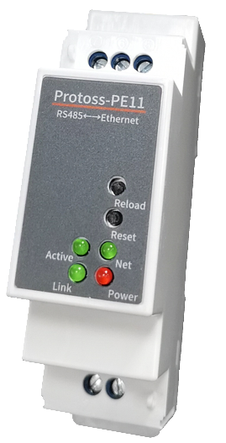 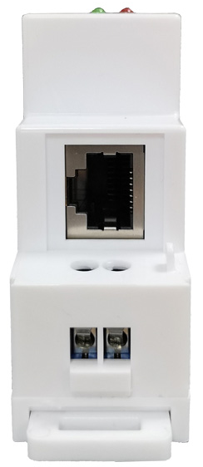 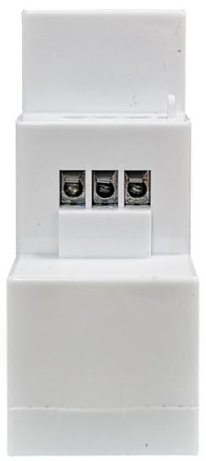 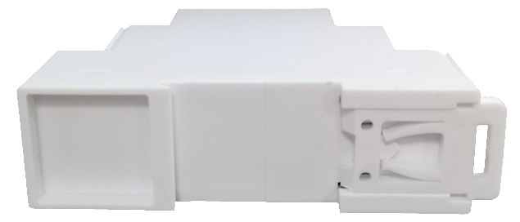

1. Protoss-PE11 Appearance

## Protoss-PE11 Pins Definition

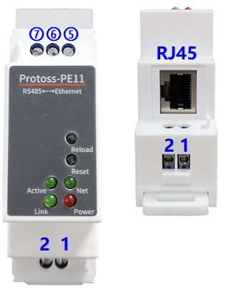

1. Protoss-PE11 Interface
2. Protoss-PE11-H Interface Definition

| **Pin** | **Description** | **Net Name** | **Signal Type** | **Comment** |
| --- | --- | --- | --- | --- |
| 1 | AC Power Input | L | Power | 100～240VAC Input |
| 2 | AC Power Input | N | Power |
| 5 |  | RS485_B- | IO | RS485 B- |
| 6 |  | RS485_A+ | IO | RS485 A+ |
| 7 | Signal GND | GND | Power | Used for RS485 GND, usually leave it unconnected |
| RJ45 | Ethernet | RJ45 | I/O |  |
| Reload | Restore to factory setting button | Reload | I | Press down for more than 3 seconds and loose to restore factory setting. |
| Reset | Reset button | Reset | I | Hardware reset button |
| Net | Network status LED | Net | O | On: Ethernet connection is OK  Off: No Ethernet connection |
| Active | UART Data Transfer | Active | O | Off: No data transfer  0.3s Off -> 0.9s On: UART TX Output  0.3s Off -> 0.3s On: UART RX Receive  On: UART bidirection. |
| Power | Power LED | Power | O | On: Power input OK  Off: Power input NG. |
| Link | Server connection LED | Link | O | On: netp Socket connection OK.  Off: no netp Socket connection. |

1. Protoss-PE11-M Interface Definition

| **Pin** | **Description** | **Net Name** | **Signal Type** | **Comment** |
| --- | --- | --- | --- | --- |
| 1 | DC Power Input | VCC+ | Power | 9～48VDC@1A Input |
| 2 | DC Power Input | GND- | Power |
| 5 |  | RS485_B- | IO | RS485 B- |
| 6 |  | RS485_A+ | IO | RS485 A+ |
| 7 | Signal GND | GND | Power | Used for RS485 GND, usually leave it unconnected |
| RJ45 | Ethernet | RJ45 | I/O |  |
| Reload | Restore to factory setting button | Reload | I | Press down for more than 3 seconds and loose to restore factory setting. |
| Reset | Reset button | Reset | I | Hardware reset button |
| Net | Network status LED | Net | O | On: Ethernet connection is OK  Off: No Ethernet connection |
| Active | UART Data Transfer | Active | O | Off: No data transfer  0.3s Off -> 0.9s On: UART TX Output  0.3s Off -> 0.3s On: UART RX Receive  On: UART bidirection. |
| Power | Power LED | Power | O | On: Power input OK  Off: Power input NG. |
| Link | Server connection LED | Link | O | On: netp Socket connection OK.  Off: no netp Socket connection. |

**<Notes>**

**I — Input; O — Output; I/O: Digital I/O; Power—Power Supply**

## RS485 Interface

RS485 use two wire links, A(DATA+), B(DATA-). Connect A(+) to A(+), B(-) to B(-) for communication. Suggest to connect GND together when interference is very severe.

The RS485 interface support maximum 32 RS485 device. The cable maximum length is 1200 meters. Need to add 120Ohm terminal resistor for over 300 meters.

## RJ45 Interface

Ethernet port is 10M/100M adaptive, support AUTO MDI/MDIX which means it support direct connecting to PC with Ethernet cable.

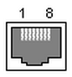

1. RJ45 Pin Defination
2. RJ45 Interface

| **Pin Number** | **Name** | **Description** |
| --- | --- | --- |
| 1 | TX+ | Transfer Data+ |
| 2 | TX- | Transfer Data- |
| 3 | RX+ | Receive Data+ |
| 4 | PHY-VCC | Transformer Tap Voltage |
| 5 | PHY-VCC | Transformer Tap Voltage |
| 6 | RX- | Receive Data- |
| 7 | N.C. | None Connect |
| 8 | N.C. | None Connect |

## Mechanical Size

The dimensions of Protoss-PE11 are defined as following picture (mm):

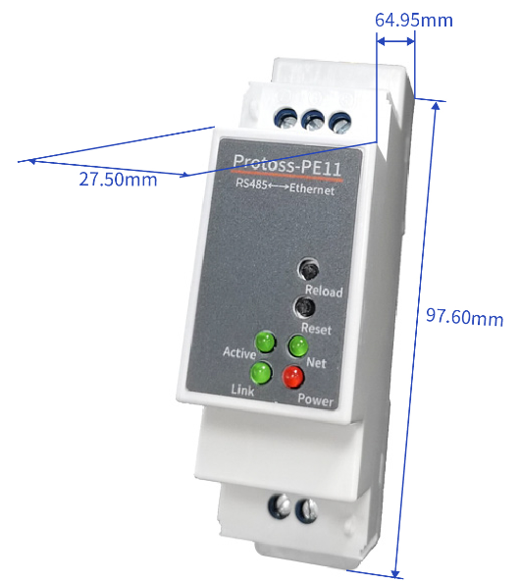

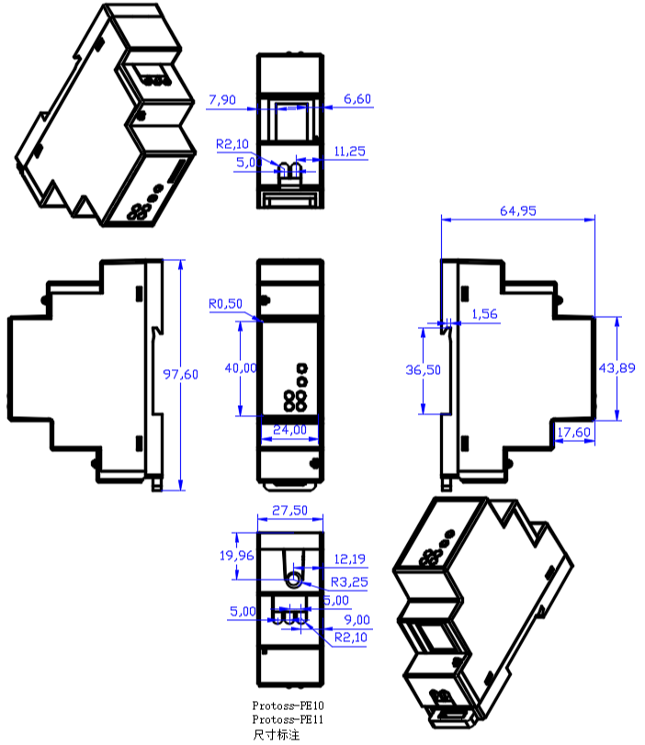

1. Protoss-PE11 Mechanical Dimension

## Product Installation

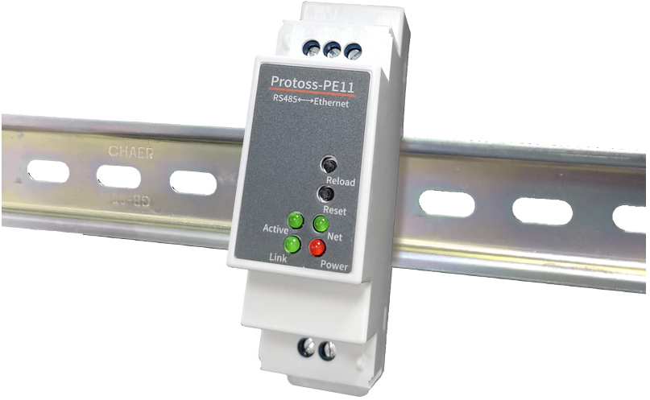

1. Product Installation

## Order Information

Base on customer detailed requirement, Protoss-PE11 provide different configuration version, Details as below:

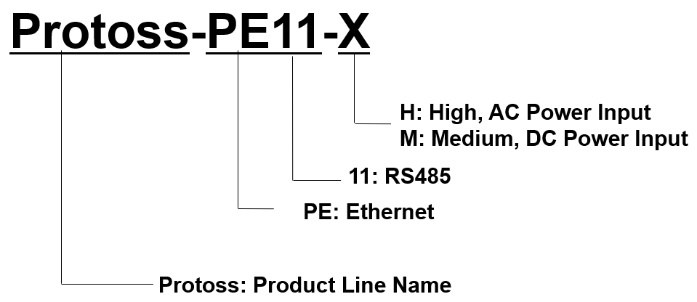

1. Protoss-PE11 Product Order Information

# 

# Function DESCRIPTION

Refer to “IOT_Device_Series_Software_Funtion” document for more detailed function.

# Appendix A: Contact Information

**------------------------------------------------------------------------------------------------------------**

**Address:** Room 1002,Building 1,No.3000,Longdong Avenue,Pudong New Area,Shanghai,China,201203

**Web:** [www.iotworkshop.com](http://www.iotworkshop.com) or [www.hi-flying.com](http://www.hi-flying.com)

**Contact:**

Sales: [sales@iotworkshop.com](mailto://sales@iotworkshop.com)

Support: [support@iotworkshop.com](mailto://support@iotworkshop.com)

Service: [service@iotworkshop.com](mailto://service@iotworkshop.com)

Business: [business@iotworkshop.com](mailto://business@iotworkshop.com)

**---------------------------------------------------------------------------- -------------------------------**

For more information about IOTworkshop modules, applications, and solutions, please visit our web site www.iotworkshop.com

**<END OF DOCUMENT>**