**HF5142**

**Super Port User Manual**

**V 1.0**

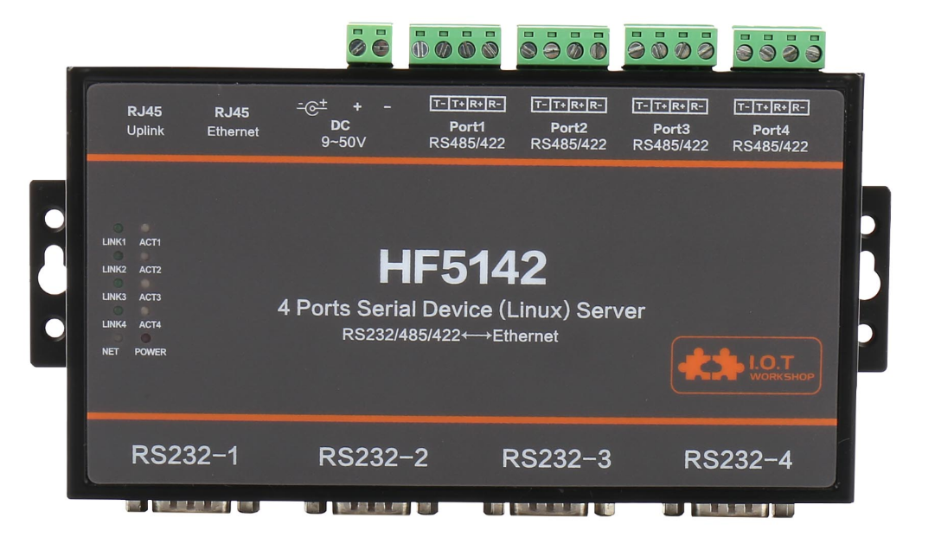

**Overview of Characteristic**

* **Internal User Four Eport-E10 or EP10 module. Support 4 dependent RS232/422/485 Interface.**
* **After Ethernet Cascade, RS232/422/485 interface can be maximum to 32 channel.**
* **Support TCP/IP/Telnet /Modbus TCP Protocol**
* **Support Serial To 10/100M Ethernet Conversion, Serial Speed Upto 921600 bps**
* **Support 10/100M Ethernet Auto-Negotiation**
* **Support Easy Configuration Through a Web Interface**
* **Support Security Protocol Such As** **TLS/AES/DES3**
* **Support Web OTA Wirelss Upgrade**
* **Support Industrial Temperature: -40 to +85˚ C**
* **Size: 197 x 165 x 25 mm (L x W x H)**
* **FCC/CE/RoHS Certificated**

# Table Of Contents Table Of Contents

Table Of Contents Table Of Contents 2

List Of Figures 3

List Of Tables 4

History 4

1. Product Overview 5

1.1. General Description 5

1.2. Device Features 5

1.3. Device Paremeters 6

1.4. Key Application 7

2. Hardware Introduction 8

2.1. Interface Definition 9

2.2. RS232 Interface 10

2.3. RS485 Interface 10

2.4. RS422 Interface 10

2.5. RJ45 Interface 11

2.6. Cascade Method 11

2.7. Mechanical Size 12

2.8. Order Information 12

2.9. Application 13

List Of Figures

Figure 1. HF5142 Appearance 8

Figure 2. HF5142 Interface Picture 9

Figure 3. RS232 Pin Defination(Male/Needle Type) 10

Figure 4. RS232 Interface 10

Figure 5. HF2211 RS422 Connection 11

Figure 6. RJ45 Pin Defination 11

Figure 7. HF5142 Cascade 12

Figure 8. HF5142 Mechanical Dimension 12

Figure 9. HF5142 Product Number Defination 13

List Of Tables

Table1. HF5142 Technical Specifications 6

Table2. HF5142 Interface 9

Table3. RJ45 Interface 11

History

**Ed. V1.0**  05-24-2017 First Version.

# Product Overview

## General Description

The HF5142 is a 4 channel RS232/RS422/RS485 Serial Server. Each channel is dependent work due to it integrate 4 Eport-E10 module.

The HF5142 support Ethernet Cascade to support 8,12,16, and max 32 Channel RS232/RS422/RS485.

## Device Features

* Internal User Four Eport-E10 or EP10 module. Support 4 dependent RS232/422/485 Interface.
* After Ethernet Cascade, RS232/422/485 interface can be maximum to 32 channel.
* Support TCP/IP/Telnet /Modbus TCP Protocol
* Support Serial To 10/100M Ethernet Conversion, Serial Speed Upto 921600 bps
* Support 10/100M Ethernet Auto-Negotiation
* Support Easy Configuration Through a Web Interface
* Support Security Protocol Such As TLS/AES/DES3
* Support Web OTA Wirelss Upgrade
* Support Industrial Temperature: -40 to +85˚ C
* Size: 197 x 165 x 25 mm (L x W x H)
* FCC/CE/RoHS Certificated

## 

## Device Paremeters

1. HF5142 Technical Specifications

|  |  |
| --- | --- |
| **Item** | **Parameters** |
| **System Information** | |
| Processor/Frequency | Cortex-M3/96MHz |
| Flash/SDRAM | 2MB/128KB |
| Operating System | FreeRTOS |
| **Ethernet Port** | |
| Port Number | 2 RJ45 with LED |
| Interface Standard | 10/100 Base-T Auto-Negotiation |
| Protection | 2KV Isolation |
| Transformer | Integrated |
| Network Protocol | IP, TCP, UDP, DHCP, DNS, HTTP Server/Client, ARP, BOOTP, AutoIP, ICMP, Web socket, Telnet, FTP,TFTP, uPNP, NTP, Modbus TCP |
| Security Protocol | TLS v1.2 AES 128Bit  DES3 |
| IPV6 Support | No |
| **Serial Port** | |
| Port Number | 4 |
| Interface Standard | RS232/RS422/RS485 |
| Data Bits | 5,6,7,8 |
| Stop Bit | 1,2 |
| Check Bit | None,Even,Odd, |
| Baud Rate | TTL: 1200 bps~460800 bps |
| Flow Control | No Flow control  Hardware RTS/CTS、DSR/DTR  Software Xon/ Xoff flow control |
| **Software** | |
| Web Pages | Http Web Configuration  Customization of HTTP Web Pages |
| Configuration | Web  CLI  XML import  Telnet  IOTManager PC Software  UART Fast Config |
| Firmware Upgrade | Web or IOTService Tools |
| SDK For Dev. | Not yet |
| **Basic Parameter** | |
| Size | 197 x 165 x 25 mm |
| Operating Temp. | -40 ~ 85°C |
| Storage Temp. | -45 ~ 105°C, 5 ~ 95% RH（no condensation） |
| Input Voltage | 9~48V |
| Working Current | ~400mA |
| Power | <4W |

## Key Application

The HF5142 device connects serial device to Ethernet networks using the TCP/IP protocol:

* Remote equipment monitoring
* Asset tracking and telemetry
* Security Application
* Industrial sensors and controls
* Medical devices
* ATM machines
* Data collection devices
* Universal Power Supply (UPS) management units

# Hardware Introduction

The HF5142 Ethernet cable connect to router for data transfer, which makes the electromechanical integration very simple. HF5142 meet EMC Class B security level,It can pass every countries relevant certification test

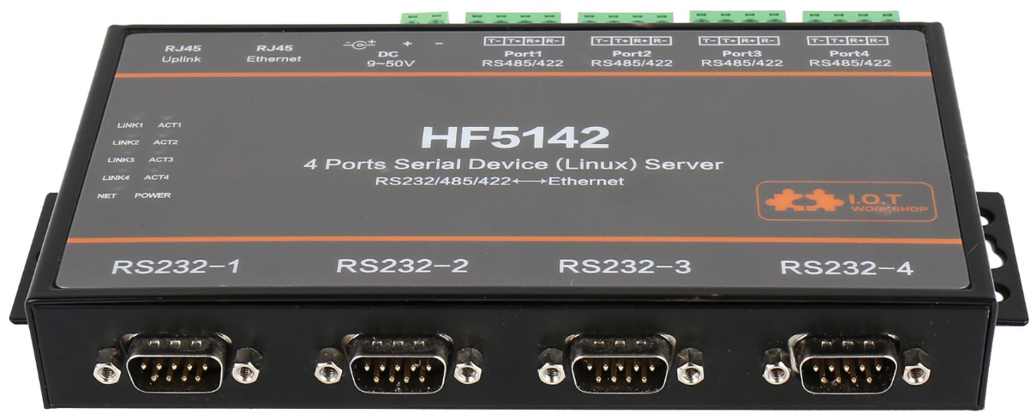

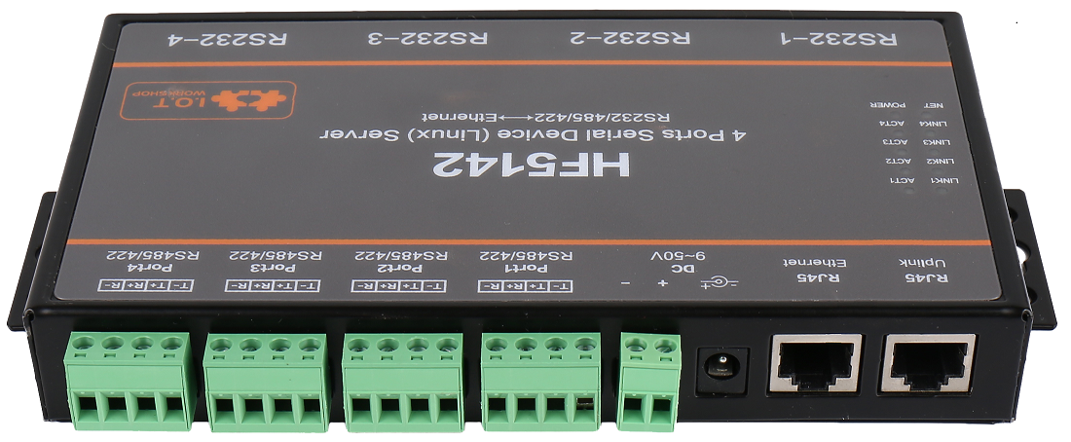

1. HF5142 Appearance

## Interface Definition

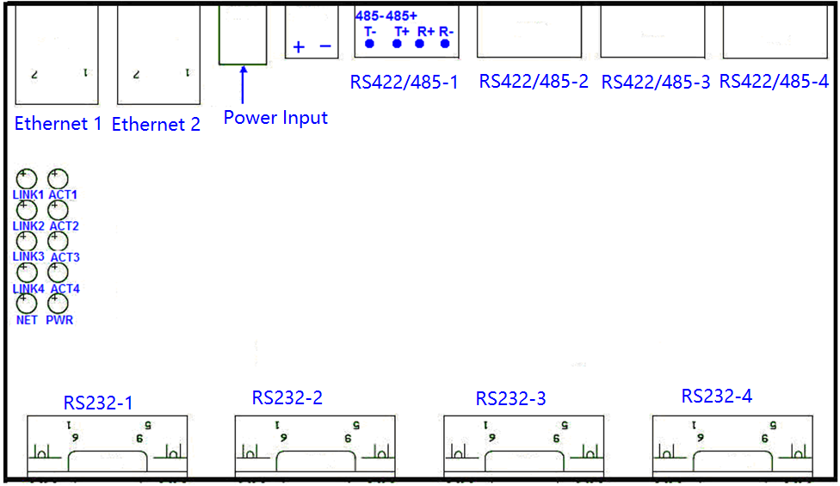

1. HF5142 Interface Picture
2. HF5142 Interface

| **Function** | **Name** | **Description** |
| --- | --- | --- |
| External Interface | Ethernet 1 | 10/100M Ethernet. Can be used to connect to router LANN port or cascaded to another HF5142 |
| Ethernet 2 | 10/100M Ethernet. Can be used to connect to router LANN port or cascaded to another HF5142 |
| Power Input | DC Power Input |
| RS232  RS485  RS422 | 4 Channel RS232/RS485/RS422 |
| LED Indicator | PWR | Internal Power Supply Indicator  On：Power is OK  Off：Power is NG |
| NET | Ethernet status |
| LINKX | 4 Channel network communication status |
| ACTX | 4 Channel UART communication status |

## RS232 Interface

Device serial port is male(needle), RS232 voltage level(can connect to PC directly), Pin Order is cosistent with PC COM port. Use cross Cable connected with PC(2-3 cross, 7-8 cross, 5-5 direct, 7-8 no connection), see the following table for pin defination.

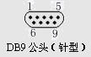

1. RS232 Pin Defination(Male/Needle Type)
2. RS232 Interface

| Pin Number | Name | Description |
| --- | --- | --- |
| 2 | RXD | Receive Data |
| 3 | TXD | Send Data |
| 5 | GND | GND |
| 7 | RTS | Request to Send |
| 8 | CTS | Clear to Send |

## RS485 Interface

RS485 use two wire links, A(DATA+), B(DATA-). Connect A(+) to A(+), B(-) to B(-) for communication.

The RS485 interface support maximum 32 485 device, special hardware version can support max 255 device. The cable maximum length is 1200 meters. Need to add 120Ohm terminal resistor for over 300 meters.

## RS422 Interface

RS422 interface use T+/T-/R+/R-, cross connect to device as the following picture.

| **Name** | **Description** |
| --- | --- |
| TX+ | Transfer Data+ |
| TX- | Transfer Data- |
| RX+ | Receive Data+ |
| RX- | Receive Data- |

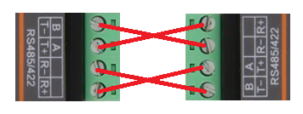

1. HF2211 RS422 Connection

## RJ45 Interface

Ethernet port is 10M/100M adaptive, support AUTO MDI/MDIX which means it support direct connecting to PC with Ethernet cable.

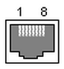

1. RJ45 Pin Defination
2. RJ45 Interface

| **Pin Number** | **Name** | **Description** |
| --- | --- | --- |
| 1 | TX+ | Transfer Data+ |
| 2 | TX- | Transfer Data- |
| 3 | RX+ | Receive Data+ |
| 4 | PHY-VCC | Transformer Tap Voltage |
| 5 | PHY-VCC | Transformer Tap Voltage |
| 6 | RX- | Receive Data- |
| 7 | N.C. | None Connect |
| 8 | N.C. | None Connect |

## Cascade Method

HF5142 support Ethernet Cascade. RS232/RS422/RS485 can be extended to max 32 channel.

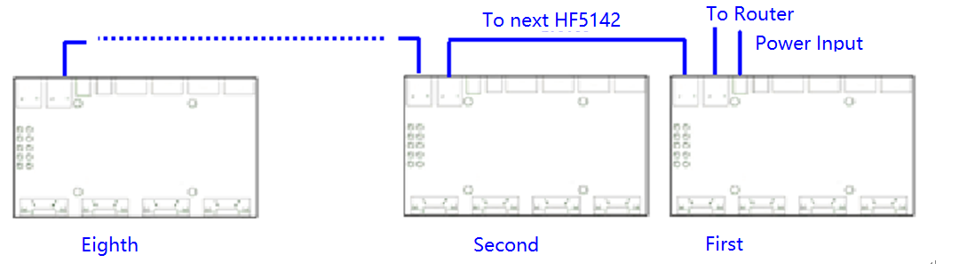

1. HF5142 Cascade

## Mechanical Size

The dimensions of HF5142 are defined as following picture (mm):

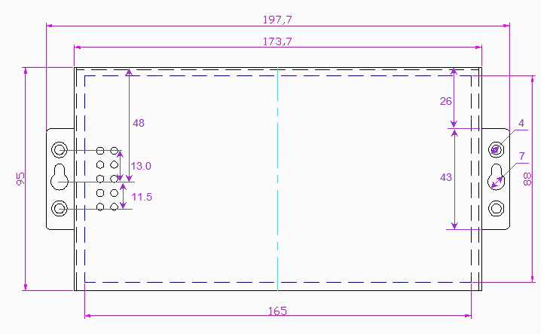

1. HF5142 Mechanical Dimension

## Order Information

Base on customer detailed requirement, HF5142 provide different configuration version, Details as below:

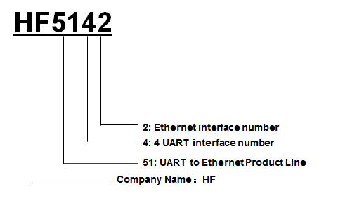

1. HF5142 Product Number Defination

## Application

See Eport-E10 manual for detailed usage..

# 