**HF5122**

**2 Ports Serial Device Server**

**User Manual**

**V 1.0**

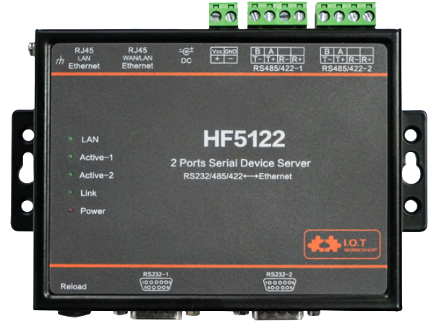

**Overview of Characteristic**

* **MIPS MCU with 4MB Flash and 8MB SRAM. Run on eCos**
* **Support TCP/IP/Telnet /Modbus TCP Protocol**
* **Support 2 channel RS232/RS422/RS485 to Ethernet Conversion, Serial Speed Upto 230400 bps**
* **Support 2 Channel 10/100M Ethernet Auto-Negotiation**
* **Support Easy Configuration Through a Web Interface or PC IOTService Tool**
* **Support Security Protocol Such As** **TLS/AES/DES3**
* **Support Web OTA Wirelss Upgrade**
* **Wide DC Input 5~36VDC**
* **Size: 108 x 146 x 25 mm (L x W x H)**

# Table Of Contents Table Of Contents

Table Of Contents Table Of Contents 3

List Of Figures 4

List Of Tables 5

History 5

1. Product Overview 6

1.1. General Description 6

1.2. Device Paremeters 6

1.3. Key Application 7

2. Hardware Introduction 8

2.1. Pins Definition 9

2.2. RS232 Interface 11

2.3. RS485 Interface 11

2.4. RS422 Interface 11

2.5. RJ45 Interface 12

2.6. Mechanical Size 12

2.7. Rail Mounting 13

2.8. Order Information 13

3. Function DESCRIPTION 15

Appendix A: Contact Information 16

List Of Figures

Figure 1. HF5122 Appearance 8

Figure 2. HF5122 Interface 9

Figure 3. HF5122 Side View 10

Figure 4. RS232 Pin Defination(Male/Needle Type) 11

Figure 5. HF5122 RS422 Connection 12

Figure 6. RJ45 Pin Defination 12

Figure 7. HF5122 Mechanical Dimension 13

Figure 8. HF5122 Rail 13

Figure 9. HF5122 Product Order Information 14

List Of Tables

Table 1. HF5122 Technical Specifications 6

Table 2. HF5122 Interface Definition 10

Table 3. RS232 Interface 11

Table 4. RJ45 Interface 12

History

**Ed. V1.0**  12-05-2019 First Version.

# Product Overview

## General Description

The HF5122 provides RS232/RS485/RS422 interface to Ethernet connectivity to web enable any device. The HF5122 integrate TCP/IP controller, memory, 10/100M Ethernet transceiver, high-speed serial port and integrates a fully developed TCP/IP network stack and eCos OS. The HF5122 also includes an embedded web server used to remotely configure, monitor, or troubleshoot the attached device.

The HF5122 using highly integrated hardware and software platform, It has been optimized for all kinds of applications in the industrial control, smart grid, personal medical application and remote control that have lower data rates, and transmit or receive data on an infrequent basis.

The HF5122 integrates all serial to Ethernet functionality with 108 x 146 x 25mm size**.**

## Device Paremeters

Table 1. HF5122 Technical Specifications

|  |  |
| --- | --- |
| **Item** | **Parameters** |
| **System Information** | |
| Processor/Frequency | MIPS/320MHz |
| Flash/SDRAM | 4MB/8MB |
| Operating System | eCos |
| **Ethernet Port** | |
| Port Number | 2 RJ45  1 WAN/LAN switchable  1 LAN |
| Interface Standard | 10/100 Base-T Auto-Negotiation |
| Protection | 8KV Isolation |
| Transformer | Integrated |
| Network Protocol | IP, TCP, UDP, DHCP, DNS, HTTP Server/Client, ARP, BOOTP, AutoIP, ICMP, Web socket, Telnet, uPNP, NTP, Modbus TCP |
| Security Protocol | TLS v1.2  AES 128Bit  DES3 |
| **Serial Port** | |
| Port Number | 2 RS232/RS485/RS422 |
| Interface Standard | RS232: DB9  RS485/RS422: 5.08mm connector  Support one channel of RS232/RS422/RS485. |
| Data Bits | 8 |
| Stop Bit | 1,2 |
| Check Bit | None, Even, Odd |
| Baud Rate | TTL: 2400 bps~230400 bps |
| Flow Control | No Flow Control  Hardware RTS/CTS、DSR/DTR  Software Xon/ Xoff flow control |
| **Software** | |
| Web Pages | Http Web Configuration  Customization of HTTP Web Pages |
| Configuration | Web  CLI  XML import  Telnet  IOTService PC Software |
| Firmware Upgrade | Web |
| **Basic Parameter** | |
| Size | 108 x 146 x 25 mm |
| Operating Temp. | -25 ~ 85°C |
| Storage Temp. | -45 ~ 105°C, 5 ~ 95% RH（no condensation） |
| Input Voltage | 5~36VDC |
| Working Current | ~200mA |
| Power | <700mW |

## Key Application

The HF5122 device connects serial device to Ethernet networks using the TCP/IP protocol:

* Remote equipment monitoring
* Asset tracking and telemetry
* Security Application
* Industrial sensors and controls
* Medical devices
* ATM machines
* Data collection devices
* Universal Power Supply (UPS) management units
* Telecommunications equipment
* Data display devices
* Handheld instruments
* Modems
* Time/attendance clocks and terminals

# Hardware Introduction

The HF5122 unit is a complete solution for serial port device connecting to network. This powerful device supports a 10/100BASE-T Ethernet connection, a reliable and proven operating system stored in flash memory, an embedded web server, a full TCP/IP protocol stack, and standards-based (AES) encryption.

Through Ethernet cable connect router with HF5122 serial server for data transfer, which makes the data transformation very simple.

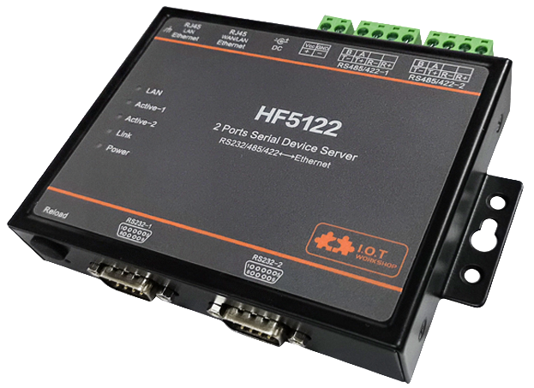

Figure 1. HF5122 Appearance

## Pins Definition

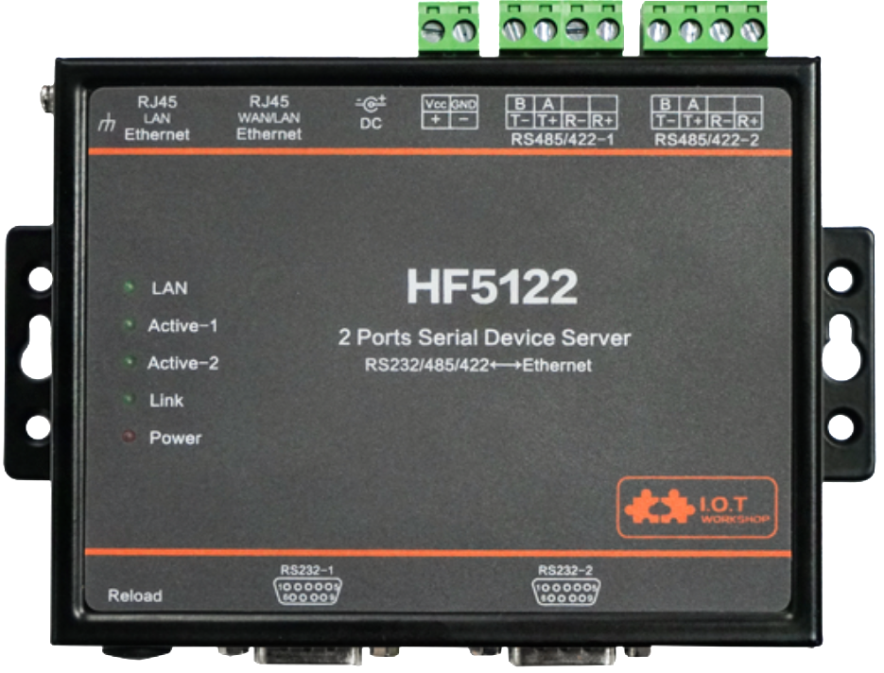

Figure 2. HF5122 Interface

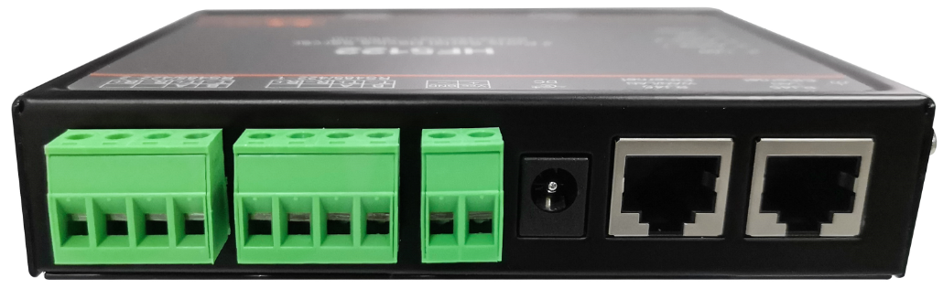

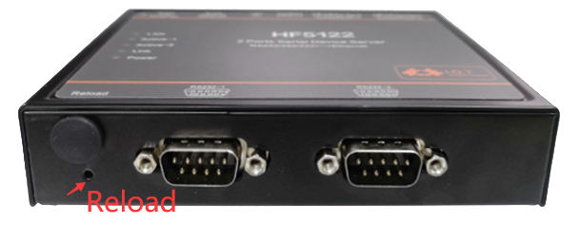

Figure 3. HF5122 Side View

Table 2. HF5122 Interface Definition

| **Function** | **Name** | **Description** |
| --- | --- | --- |
| External Interface | Ethernet 1 | 10/100M Ethernet  LAN function |
| Ethernet 2 | 10/100M Ethernet  Default is WAN function, connect to router LAN port for network access. Can be configured to LAN Function |
| RS232/RS422/RS485-1 | UART1 Channel |
| RS232/RS422/RS485-2 | UART2 Channel |
| Earth | Protect Earth |
| DC Power Input | DC Power 5~36V |
| LED Indicator | Power | Internal Power Supply Indicator  On: Power is OK  Off: Power is NG |
| LAN(Net-2) | Ethernet 1 Connection Indicator  On: Ethernet connection is OK  Off: No Ethernet connection |
| Active-1 | UART1 channel data transfer Indicator  Flash: Send data  Off: No data sent |
| Active-2 | UART2 channel data transfer Indicator  Flash: Send data.  Off: No data sent |
| Link | Network Connection Indicator  On: Include the following condition.   * Ethernt 2 connection OK   Off: No network connection |
| Button | Reload(Reset) | Press down for 4 seconds and then up, the device will restore to factory setting and reboot. |

## RS232 Interface

Device serial port is male(needle), RS232 voltage level(can connect to PC directly), Pin Order is cosistent with PC COM port. Use cross Cable connected with PC(2-3 cross, 7-8 cross, 5-5 direct, 7-8 no connection), see the following table for pin defination.

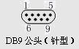

Figure 4. RS232 Pin Defination(Male/Needle Type)

Table 3. RS232 Interface

| Pin Number | Name | Description |
| --- | --- | --- |
| 2 | RXD | Receive Data |
| 3 | TXD | Send Data |
| 5 | GND | GND |
| 7 | RTS | Request to Send |
| 8 | CTS | Clear to Send |

## RS485 Interface

RS485 use two wire links, A(DATA+), B(DATA-). Connect A(+) to A(+), B(-) to B(-) for communication.

The RS485 interface support maximum 32 485 device, special hardware version can support max 255 device. The cable maximum length is 1200 meters. Need to add 120Ohm terminal resistor for over 300 meters.

## RS422 Interface

RS422 interface use T+/T-/R+/R-, cross connect to device as the following picture.

| **Name** | **Description** |
| --- | --- |
| TX+ | Transfer Data+ |
| TX- | Transfer Data- |
| RX+ | Receive Data+ |
| RX- | Receive Data- |

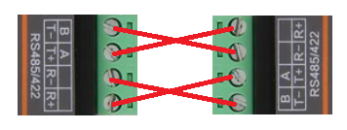

Figure 5. HF5122 RS422 Connection

## RJ45 Interface

Ethernet port is 10M/100M adaptive, support AUTO MDI/MDIX which means it support direct connecting to PC with Ethernet cable.

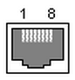

Figure 6. RJ45 Pin Defination

Table 4. RJ45 Interface

| **Pin Number** | **Name** | **Description** |
| --- | --- | --- |
| 1 | TX+ | Transfer Data+ |
| 2 | TX- | Transfer Data- |
| 3 | RX+ | Receive Data+ |
| 4 | PHY-VCC | Transformer Tap Voltage |
| 5 | PHY-VCC | Transformer Tap Voltage |
| 6 | RX- | Receive Data- |
| 7 | N.C. | None Connect |
| 8 | N.C. | None Connect |

## Mechanical Size

The dimensions of HF5122 are defined as following picture (mm):

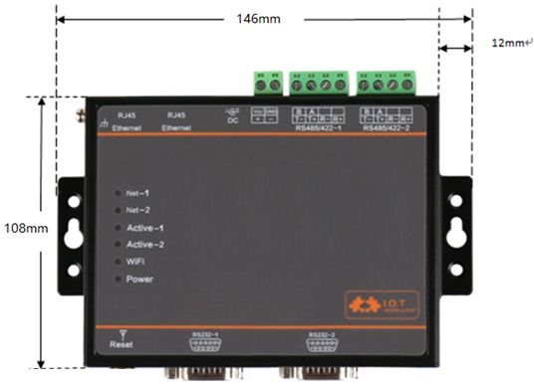

Figure 7. HF5122 Mechanical Dimension

## Rail Mounting

We support to provide rail for mounting as the following picture.

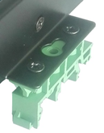 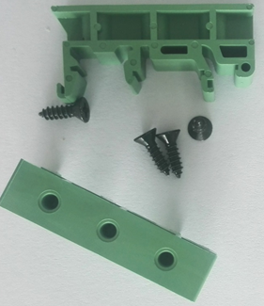

Figure 8. HF5122 Rail

## Order Information

HF5122 is defined as following.

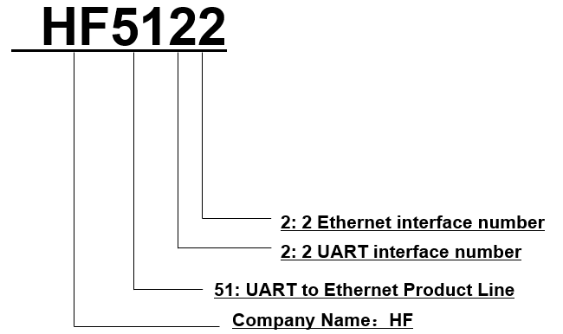

Figure 9. HF5122 Product Order Information

# 

# Function DESCRIPTION

Refer to “IOT_Device_Series_Software_Funtion” document for more detailed function.

# 

# Appendix A: Contact Information

**------------------------------------------------------------------------------------------------------------**

**Address:** Room 1002,Building 1,No.3000,Longdong Avenue,Pudong New Area,Shanghai,China,201203

**Web:** [www.iotworkshop.com](http://www.iotworkshop.com) or [www.hi-flying.com](http://www.hi-flying.com)

**Contact:**

Sales: [sales@iotworkshop.com](mailto://sales@iotworkshop.com)

Support: [support@iotworkshop.com](mailto://support@iotworkshop.com)

Service: [service@iotworkshop.com](mailto://service@iotworkshop.com)

Business: [business@iotworkshop.com](mailto://business@iotworkshop.com)

**---------------------------------------------------------------------------- -------------------------------**

For more information about IOTworkshop modules, applications, and solutions, please visit our web site www.iotworkshop.com

**<END OF DOCUMENT>**