**HF5111A**

**Serial Server Device User Manual**

**V 1.2**

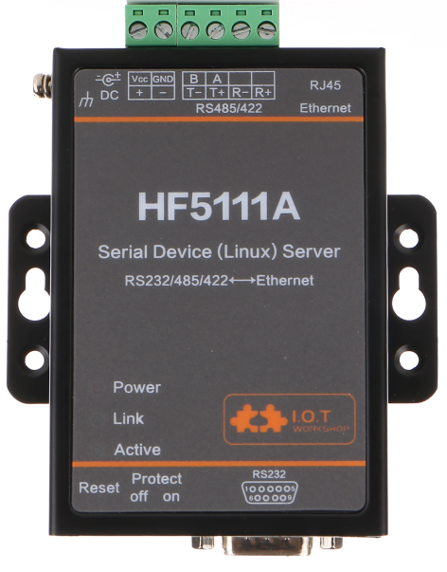

**Overview of Characteristic**

* **MIPS MCU with 16MB Flash and 32MB SRAM**
* **Use Linux Operation System**
* **Support TCP/IP/Telnet /Modbus TCP Protocol**
* **Support Serial To 10/100M Ethernet Conversion, Serial Speed Upto 460800 bps**
* **Support 10/100M Ethernet Auto-Negotiation**
* **Support Easy Configuration Through a Web Interface or PC IOTService Tool**
* **Support Security Protocol Such As** **TLS/AES/DES3**
* **Support Web OTA Wirelss Upgrade**
* **Wide DC Input 5~36VDC**
* **Size: 95 x 65 x 25 mm (L x W x H)**
* **FCC/CE/RoHS Certificated**

# Table Of Contents Table Of Contents

Table Of Contents Table Of Contents 2

List Of Figures 3

List Of Tables 4

History 4

1. Product Overview 5

1.1. General Description 5

1.2. Device Paremeters 5

1.3. Key Application 6

2. Hardware Introduction 7

2.1. Pins Definition 8

2.2. RS232 Interface 9

2.3. RS485 Interface 10

2.4. RS422 Interface 10

2.5. RJ45 Interface 10

2.6. Mechanical Size 11

2.7. Rail Mounting 11

2.8. Order Information 12

2.9. Software Function 12

Appendix A: Contact Information 13

List Of Figures

Figure 1. HF5111A Appearance 7

Figure 2. HF5111A Interface 8

Figure 3. HF5111A Side View 8

Figure 4. RS232 Pin Defination(Male/Needle Type) 9

Figure 5. HF5111A RS422 Connectioin 10

Figure 6. RJ45 Pin Defination 10

Figure 7. HF5111A Mechanical Dimension 11

Figure 8. HF5111A Rail 12

Figure 9. HF5111A Product Order Information 12

List Of Tables

Table1. HF5111A Technical Specifications 5

Table2. HF5111A Interface Definition 9

Table3. RS232 Interface 9

Table4. RJ45 Interface 11

History

**Ed. V1.0**  11-08-2016 First Version

**Ed. V1.1**  03-03-2017 Add Auto-IP, heartbeat, ntp and UART fast config function(Firmware version:1.07d)

**Ed. V1.2**  04-16-2019 Update software function to another document.

# Product Overview

## General Description

The HF5111A provides a serial interface to Ethernet connectivity to web enable any device. The HF5111A integrate TCP/IP controller, memory, 10/100M Ethernet transceiver, high-speed serial port and integrates a fully developed TCP/IP network stack and Linux OS.The HF5111A also includes an embedded web server used to remotely configure, monitor, or troubleshoot the attached device.

The HF5111A using highly integrated hardware and software platform,It has been optimized for all kinds of applications in the industrial control, smart grid , personal medical application and remote control that have lower data rates, and transmit or receive data on an infrequent basis.

The HF5111A integrates all serial to Ethernet functionality with 95 x 65 x 25mm size..

## Device Paremeters

1. HF5111A Technical Specifications

|  |  |
| --- | --- |
| **Item** | **Parameters** |
| **System Information** | |
| Processor/Frequency | MIPS/320MHz |
| Flash/SDRAM | 16MB/32MB |
| Operating System | Linux |
| **Ethernet Port** | |
| Port Number | 1 RJ45 |
| Interface Standard | 10/100 Base-T Auto-Negotiation |
| Protection | 8KV Isolation |
| Transformer | Integrated |
| Network Protocol | IP，TCP，UDP，DHCP，DNS，HTTP Server/Client，ARP, BOOTP, AutoIP, ICMP，Web socket, Telnet, uPNP, NTP,Modbus TCP |
| Security Protocol | TLS v3  AES 128Bit  DES3 |
| **Serial Port** | |
| Port Number | 1 RS232/RS485/RS422 |
| Interface Standard | RS232: DB9  RS485/RS422: 5.08mm connector |
| Data Bits | 8 |
| Stop Bit | 1,2 |
| Check Bit | None,Even,Odd |
| Baud Rate | TTL: 2400 bps~460800 bps |
| Flow Control | No Flow control  Hardware RTS/CTS、DSR/DTR  Software Xon/ Xoff flow control |
| **Software** | |
| Web Pages | Http Web Configuration  Customization of HTTP Web Pages |
| Configuration | Web  CLI  XML import  Telnet  IOTService PC Software  UART Fast Config |
| Firmware Upgrade | Web, IOTService Tools |
| SDK For Dev. | Support |
| **Basic Parameter** | |
| Size | 95 x 65 x 25 mm |
| Operating Temp. | -25 ~ 70°C |
| Storage Temp. | -45 ~ 105°C, 5 ~ 95% RH（no condensation） |
| Input Voltage | 5~36VDC |
| Working Current | ~200mA |
| Power | <700mW |

## Key Application

The HF5111A device connects serial device to Ethernet networks using the TCP/IP protocol:

* Remote equipment monitoring
* Asset tracking and telemetry
* Security Application
* Industrial sensors and controls
* Medical devices
* ATM machines
* Data collection devices
* Universal Power Supply (UPS) management units
* Telecommunications equipment
* Data display devices
* Handheld instruments
* Modems
* Time/attendance clocks and terminals

# Hardware Introduction

The HF5111A unit is a complete solution for serial port device connecting to network. This powerful device supports a 10/100BASE-T Ethernet connection, a reliable and proven operating system stored in flash memory, an embedded web server, a full TCP/IP protocol stack,and standards-based (AES) encryption.

Through Ethernet cable connect router with HF5111A serial server for data transfer, which makes the data transformation very simple. HF5111A meet EMC Class B security level,It can pass every countries relevant certification test

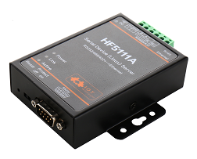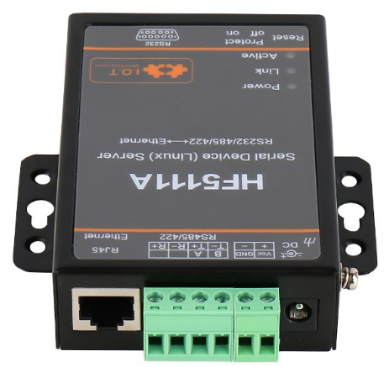

1. HF5111A Appearance

## 

## Pins Definition

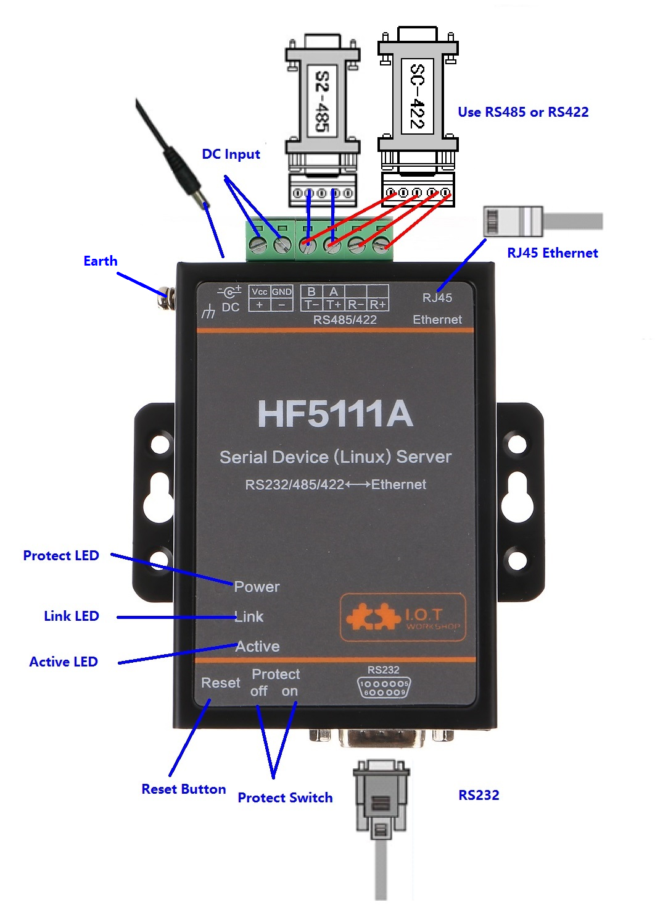

1. HF5111A Interface

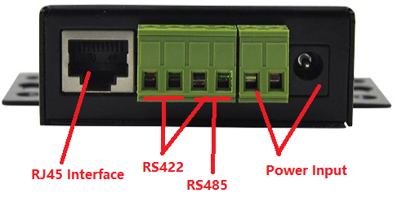

1. HF5111A Side View
2. HF5111A Interface Definition

| **Function** | **Name** | **Description** |
| --- | --- | --- |
| External Interface | RJ45 Ethernet | 10/100M Ethernet |
| RS232 | RS232 Communication |
| RS485/RS422 | RS485/RS422 Communicaton |
| Earth | Protect Earth |
| DC Input | DC Power 5~36V |
| LED Indicator | Power | Internal Power Supply Indicator  On：Power is OK  Off：Power is NG |
| Link | Connection Indicator  On: Ethernet connection is OK  Off: No Ethernet connection |
| Active | Data transfer Indicator  On：Data is transfering.  Off：No data transfer |
| Button | Reset | Reset device |
| Switch | Protect | Device parameter protect  On: Enable protect, working parameter can not be modified.  Off: Disable protect. |

## RS232 Interface

Device serial port is male(needle), RS232 voltage level(can connect to PC directly), Pin Order is cosistent with PC COM port. Use cross Cable connected with PC(2-3 cross, 7-8 cross, 5-5 direct, 7-8 no connection), see the following table for pin defination.

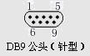

1. RS232 Pin Defination(Male/Needle Type)
2. RS232 Interface

| Pin Number | Name | Description |
| --- | --- | --- |
| 2 | RXD | Receive Data |
| 3 | TXD | Send Data |
| 5 | GND | GND |
| 7 | RTS | Request to Send |
| 8 | CTS | Clear to Send |

## RS485 Interface

RS485 use two wire links, A(DATA+), B(DATA-). Connect A(+) to A(+), B(-) to B(-) for communication.

The RS485 interface support maximum 32 485 device, special hardware version can support max 255 device. The cable maximum length is 1200 meters. Need to add 120Ohm terminal resistor for over 300 meters.

## RS422 Interface

RS422 interface use T+/T-/R+/R-, cross connect to device as the following picture.

| **Name** | **Description** |
| --- | --- |
| TX+ | Transfer Data+ |
| TX- | Transfer Data- |
| RX+ | Receive Data+ |
| RX- | Receive Data- |

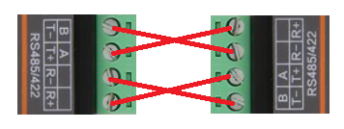

1. HF5111A RS422 Connectioin

## RJ45 Interface

Ethernet port is 10M/100M adaptive, support AUTO MDI/MDIX which means it support direct connecting to PC with Ethernet cable.

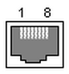

1. RJ45 Pin Defination
2. RJ45 Interface

| **Pin Number** | **Name** | **Description** |
| --- | --- | --- |
| 1 | TX+ | Transfer Data+ |
| 2 | TX- | Transfer Data- |
| 3 | RX+ | Receive Data+ |
| 4 | PHY-VCC | Transformer Tap Voltage |
| 5 | PHY-VCC | Transformer Tap Voltage |
| 6 | RX- | Receive Data- |
| 7 | N.C. | None Connect |
| 8 | N.C. | None Connect |

## Mechanical Size

The dimensions of HF5111A are defined as following picture (mm):

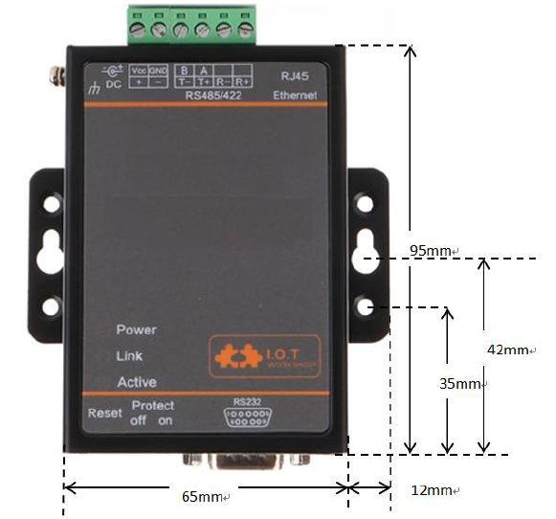

1. HF5111A Mechanical Dimension

## Rail Mounting

We support to provide rail for mounting as the following picture.

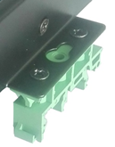 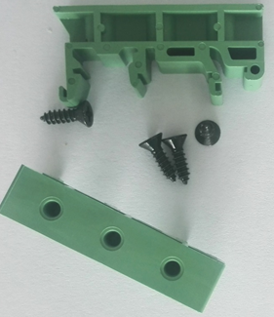

1. HF5111A Rail

## Order Information

Base on customer detailed requirement, HF5111A provide different configuration version, Details as below:

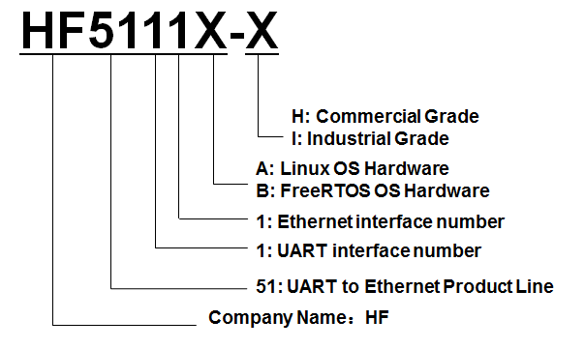

1. HF5111A Product Order Information

## Software Function

Refer to “IOT_Device_Series_Software_Funtion” document for detailed usage.

# Appendix A: Contact Information

**------------------------------------------------------------------------------------------------------------**

**Address:** Room 1002,Building 1,No.3000,Longdong Avenue,Pudong New Area,Shanghai,China,201203

**Web:** [www.iotworkshop.com](http://www.iotworkshop.com) or [www.hi-flying.com](http://www.hi-flying.com)

**Contact:**

Sales: [sales@iotworkshop.com](mailto://sales@iotworkshop.com)

Support: [support@iotworkshop.com](mailto://support@iotworkshop.com)

Service: [service@iotworkshop.com](mailto://service@iotworkshop.com)

Business: [business@iotworkshop.com](mailto://business@iotworkshop.com)

**---------------------------------------------------------------------------- -------------------------------**

For more information about IOTworkshop modules, applications, and solutions, please visit our web site www.iotworkshop.com

**<END OF DOCUMENT>**