**HF2111A**

**GPRS DTU User Manual**

**V 1.0**

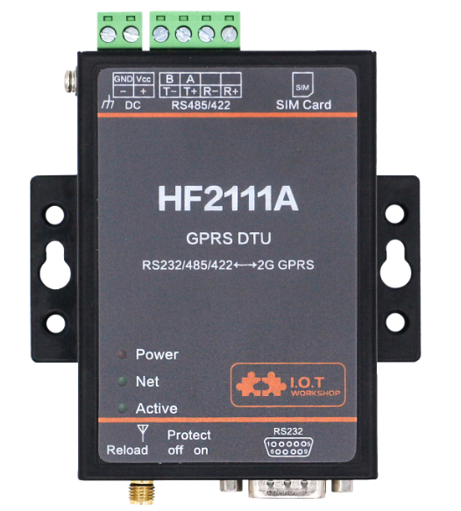

**Overview of Characteristic**

* Support GPRS(850/900/1800/1900MHz)
* Support RS232/RS485 to GPRS Data Transmission, UART baud rate Up to 460800bps
* Supports Max 3 Channel TCP/UDP connections, Each Connection Supports 1400 Bytes of Data Cache
* Support Multiple Working Modes: Network Transparent Transmission Mode, HTTP Mode
* Support IOTService Tool, Remotely and Dynamically Modify Module Parameters
* Support SMS AT Command Configuration
* Supports Registration Packet, Heartbeat Packet Function, and Packet Supports Combination of ICCID, IMEI, IMSI, Software Version, GPRS Connection Status.
* Support NTP
* Support Modbus TCP to Modbus RTU
* Support IOTBridge for Remote Control and Config
* Support IOTBridge Working Time Setting, For Example, Only Works From 10:00 to 10:30 to Save the Data Traffic
* Support UART, Network OTA Upgrade Firmware
* Size: 95 x 65 x 25mm
* 9～36VDC Wide Power Supply

# Table of contents

Table of contents 3

list of figures 4

list of tables 4

1. Product OVERVIER 5

1.1. General Description 5

1.2. Device Parameters 5

1.3. Key Applications 6

2. hardware introduction 7

2.1. Appearance 7

2.2. HF2111A Interface 8

2.3. RS232 Interface 9

2.4. RS485 Interface 9

2.5. Mechanical Size 9

2.6. Product Order Information 10

APPENDIX A: CONTACT INFORMATION 12

list of figures

Figure 1. HF2111A Appearance 7

Figure 2. HF2111A Interface 8

Figure 3. RS232 Pin Defination(Male/Needle Type) 9

Figure 4. HF2111A Mechanical Size 10

Figure 5. HF2111A Product Order Information 11

list of tables

Table1. HF2111A Technical Specifications 5

Table2. HF2111A Interface Definition 8

Table3. RS232 Interface 9

**HISTORY**

**V 1.0** 12-07-2018. First Version

# Product OVERVIER

## General Description

The HF2111A support GPRS/GSM

The HF2111A support TCPIP protocol, with its RS232/RS485 interface, it make traditional UART device easy connecting to IOT.

## Device Parameters

1. HF2111A Technical Specifications

|  |  |
| --- | --- |
| **Item** | **Parameters** |
| **Wireless Parameter** | |
| GPRS Band | GSM850, EGSM900, DCS1800, PCS1900 |
| GPRS Transmit Power | GPRS transmit power GSM850/EGSM900: 5dbm~32.5dbm  DCS1800/PCS1900: 0dbm~29.5dbm |
| GPRS Receiving Sensitivity | <-108.5dBm |
| GPRS Connection Feature | GPRS multi-slot level is 10 (default)  GPRS mobile station level B |
| GPRS Data Characteristics | GPRS data downlink transmission: up to 85.6 kbps  GPRS data uplink transmission: up to 85.6 kbps  Encoding format: CS-1, CS-2, CS-3 and CS-4 |
| GPRS Antenna Interface Characteristic Impedance | 50Ω |
| **Serial Port** | |
| Port Number | 1 |
| Interface Standard | RS232: DB9  RS485: 5.08mm connector  Choose either RS232 or RS485. |
| Data Bits | 7,8 |
| Stop Bit | 1,2 |
| Check Bit | None,Even,Odd |
| Baud Rate | TTL：2400 bps~460800 bps |
| Flow Control | No Flow control  Half-Duplex(RS485)  Hardware RTS/CTS、DSR/DTR(RS232) |
| **Software** | |
| Configuration | Serial AT Command  IOTService Serial Port Configuration Software  IOTService Network Configuration Software |
| Firmware Upgrade | UART or OTA Upgrade |
| **Basic Parameter** | |
| SIM Card | Standard SIM card(1.8V/3V) |
| Size | 95mm x 65mm x 25mm |
| Operating Temp. | -40 ~ 85°C |
| Storage Temp. | -45 ~ 105°C, 5 ~ 95% RH（no condensation） |
| Input Voltage | 9~36VDC |
| Working Current | ~300mA@9V |

## Key Applications

The HF2111A module connects the serial device to the Internet and conforms to the TCP/IP protocol for transmitting serial data.

* Remote device monitoring
* Production asset tracking and monitoring
* Security field
* Industrial sensors and controllers
* Health medical equipment
* ATM equipment
* Data acquisition equipment
* UPS power management equipment
* Telecommunication equipment
* Data display device
* Hand-held device
* Attendance system and terminal equipment

# hardware introduction

HF2111A is a GPRS solution for serial device networking. Data transmission via GPRS makes product integration very easy. This product meets EMC Class B security level and can pass relevant certification tests in various countries.

## Appearance

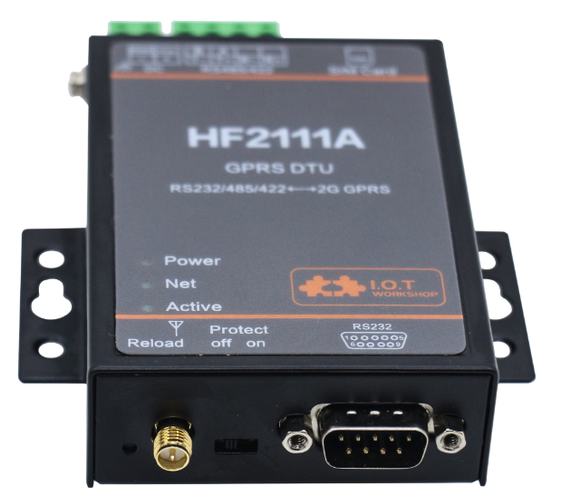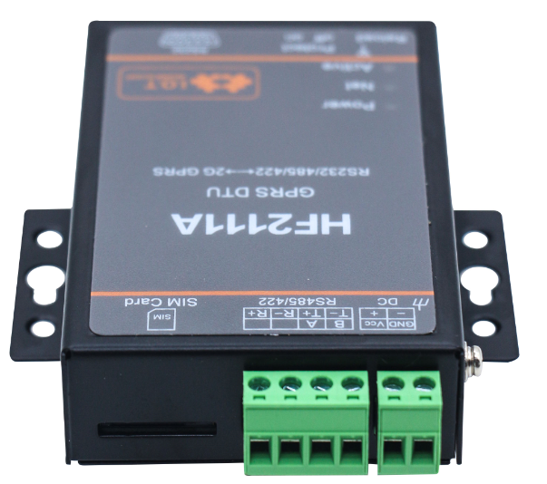

1. HF2111A Appearance

## HF2111A Interface



1. HF2111A Interface
2. HF2111A Interface Definition

| **Function** | **Name** | **Description** |
| --- | --- | --- |
| External Interface | DC | DCPower 9~36V Input |
| RS485/RS232 | RS485 A+ Connector  RS485 B- Connector  RS232 Rxd Connector  RS232 Txd Connector  Use either RS485 or RS232(Can not work both) |
| SIM Card | Standard Sim Card Slot |
| Earth | Connect to Protect GND |
| Antenna | GPRS SMA Antenna |
| RS232 | 9-PIN RS232 |
| LED Indicator | NET | Network Status LED(Function is reserved)  Off: No network connection  2s On -> 2s Off: Network connection is OK  100ms On -> 100ms Off: Network is in transferring |
| Active | UART Data Bi-Color LED  Blue On: UART data output  Green On: UART data input |
| Power | 3.3V Internal Power Supply LED |
| Button | Reload | Long press 3 seconds down and loose to restore parameters to factory setting |
| Switch | Protect | Parameter Protect (Function is Reserved) |

## RS232 Interface

Device serial port is male(needle), RS232 voltage level(can connect to PC directly), Pin Order is cosistent with PC COM port. Use cross Cable connected with PC(2-3 cross, 7-8 cross, 5-5 direct), see the following table for pin defination.

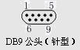

1. RS232 Pin Defination(Male/Needle Type)
2. RS232 Interface

| **Pin Number** | **Name** | **Description** |
| --- | --- | --- |
| 2 | RXD | Receive Data |
| 3 | TXD | Send Data |
| 5 | GND | GND |
| 7 | RTS | Request to Send |
| 8 | CTS | Clear to Send |

## RS485 Interface

RS485 use two wire links, A(DATA+), B(DATA-). Connect A(+) to A(+), B(-) to B(-) for communication. Suggest to connect GND together when interference is very severe.

The RS485 interface support maximum 32 485 device, device. The cable maximum length is 1200 meters. Need to add 120Ohm terminal resistor for over 300 meters.

## Mechanical Size

The dimensions of HF2111A are defined as following pictures(mm):

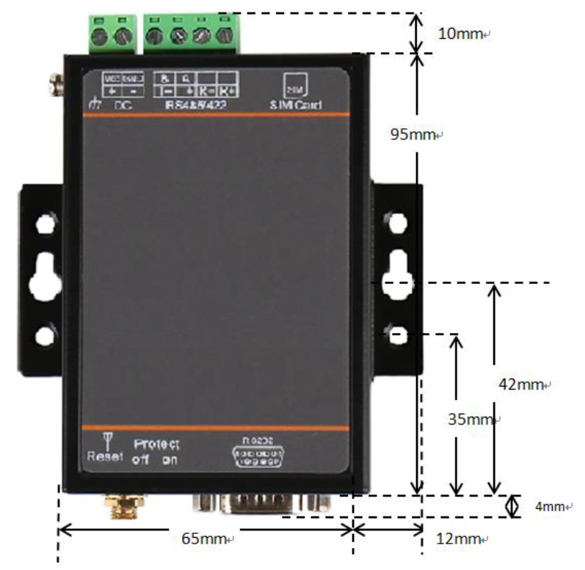

1. HF2111A Mechanical Size

## Product Order Information

Based on customers detailed requirements, we provide different configuration HF2111A, details as below:

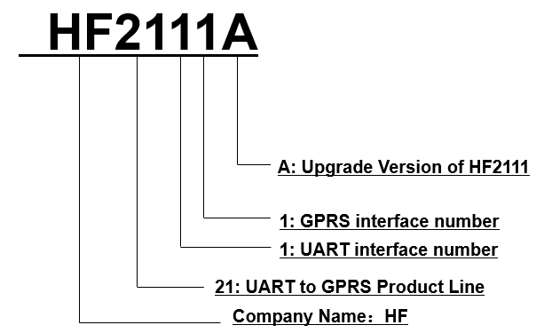

1. HF2111A Product Order Information

# 

# APPENDIX A: CONTACT INFORMATION

**------------------------------------------------------------------------------------------------------------**

**Address:** Room1002 , #1Building, No.3000 Longdong Avenue, Pudong District, Shanghai, China   201202

**Website:** [www.iotworkshop.com](http://www.iotworkshop.com) or [www.hi-flying.com](http://www.hi-flying.com)

**Contact:**

Sales：[sales@iotworkshop.com](mailto://sales@iotworkshop.com)

Support：[support@iotworkshop.com](mailto://support@iotworkshop.com)

Service：[service@iotworkshop.com](mailto://service@iotworkshop.com)

Business：[business@iotworkshop.com](mailto://business@iotworkshop.com)

**---------------------------------------------------------------------------- -------------------------------**

**For more information about us, please visit our website: www.iotworkshop.com**

**< END OF DOCUMENT >**