**Eport-E30**

**Ethernet Serial Server**

**User Manual**

**V 1.1**

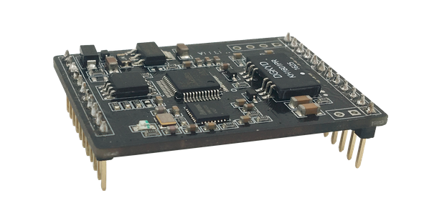

**Overview of Characteristic**

* **Cortex-M3 MCU with 2MB Flash and 128KB SRAM**
* **Use FreeRTOS Operation System**
* **Support TCP/IP/Telnet /Modbus TCP Protocol**
* **Support Serial To 10/100M Ethernet Conversion, Serial Speed Upto 460800 bps**
* **Support 10/100M Ethernet Auto-Negotiation**
* **Support Easy Configuration Through a Web Interface or PC IOTService Tools**
* **Support Security Protocol Such As** **TLS/AES/DES3**
* **Support Web OTA Wirelss Upgrade**
* **Support Industrial Temperature: -25 to +85˚ C**
* **Wide 5V～9V Power Supply**
* **Size: 45 x 32 x 8 mm (L x W x H)**

# Table Of Contents Table Of Contents

Table Of Contents Table Of Contents 2

List Of Figures 3

List Of Tables 4

History 4

1. Product Overview 5

1.1. General Description 5

1.2. Device Features 5

1.3. Device Paremeters 6

1.4. Key Application 7

2. Hardware Introduction 8

2.1. Pins Definition 8

2.2. Electrical Characteristics 10

2.3. Ethernet Interface 10

2.4. Mechanical Size 10

2.5. Order Information 11

2.6. Function 12

List Of Figures

Figure 1. Eport-E30 Appearance 8

Figure 2. Eport-E30 Pins Map 8

Figure 3. Eport-E30 Mechanical Dimension 11

Figure 4. Eport-E30 Product Number Defination 11

List Of Tables

Table1. Eport-E30 Module Technical Specifications 6

Table2. Eport-E30 Pins Definition 9

Table3. Absolute Maximum Ratings: 10

Table4. Power Supply & Power Consumption: 10

Table5. Ethernet Interface Definition 10

History

**Ed. V1.0**  05-25-2017 First Version

**Ed. V1.1**  12-14-2018 Fix working temperature

# Product Overview

## General Description

The Eport-E30 is a fully self-contained integrated solution, which provide a serial interface to Ethernet connectivity to web enable any device. The Eport-E30 integrate TCP/IP controller, memory, 10/100M Ethernet transceiver, high-speed serial port and integrates a fully developed TCP/IP network stack and FreeRTOS OS.The Eport-E30 also includes an embedded web server used to remotely configure, monitor, or troubleshoot the attached device.

## Device Features

* Cortex-M3 MCU with 2MB Flash and 128KB SRAM
* Full Integrated RJ45 Solution
* Support FreeRTOS Operation System
* Support TCP/IP、UDP、DHCP、DNS、HTTP Server/Client、ARP、BOOTP、AutoIP、ICMP、Telnet、FTP、TFTP、uPNP、NTP、ModbusTCP Protocol
* Support Serial to 10/100M Ethernet Conversion, Serial Speed Upto 921600 bps
* Support 10/100M Ethernet Auto-Negotiation
* Support Easy Configuration Through a Web Interface
* Support Security Protocol Such As TLS/AES/DES3
* Support Web Wireless Upgrade
* Support Industrial Temperature: -25 to +85˚ C

## 

## Device Paremeters

1. Eport-E30 Module Technical Specifications

|  |  |
| --- | --- |
| **Item** | **Parameters** |
| **System Information** | |
| Processor/Frequency | Cortex-M3/96MHz |
| Flash/SDRAM | 2MB/128KB |
| Operating System | FreeRTOS |
| **Ethernet Port** | |
| Port Number | 1 RJ45 with LED |
| Interface Standard | 10/100 Base-T Auto-Negotiation |
| Protection | 2KV Isolation |
| Transformer | Integrated |
| Network Protocol | IP, TCP, UDP, DHCP, DNS, HTTP Server/Client, ARP, BOOTP, AutoIP, ICMP, Web socket, Telnet, FTP,TFTP, uPNP, NTP, Modbus TCP |
| Security Protocol | TLS v1.2 AES 128Bit  DES3 |
| IPV6 Support | No |
| **Serial Port** | |
| Port Number | 1 + 1 debug |
| Interface Standard | 3.3V TTL: 2 wire（TX,RX） |
| Data Bits | 5,6,7,8 |
| Stop Bit | 1,2 |
| Check Bit | None,Even,Odd,Space,Mark |
| Baud Rate | TTL: 2400 bps~460800 bps |
| Flow Control | No Flow control  Hardware RTS/CTS、DSR/DTR  Software Xon/ Xoff flow control |
| **Software** | |
| Web Pages | Http Web Configuration  Customization of HTTP Web Pages |
| Configuration | Web  CLI  XML import  Telnet  IOTService PC Software  UART Fast Config |
| Firmware Upgrade | Web or IOTService |
| SDK For Dev. | Not yet |
| **Basic Parameter** | |
| Size | 45 x 32 x 8 mm |
| Operating Temp. | -25 ~ 85°C |
| Storage Temp. | -45 ~ 105°C, 5 ~ 95% RH（no condensation） |
| Input Voltage | 5V~9V |
| Working Current | ~100mA |
| Power | <400mW |

## Key Application

The Eport-E30 device connects serial device to Ethernet networks using the TCP/IP protocol:

* Remote equipment monitoring
* Asset tracking and telemetry
* Security Application
* Industrial sensors and controls
* Medical devices
* ATM machines
* Data collection devices
* Universal Power Supply (UPS) management units
* Telecommunications equipment
* Data display devices
* Handheld instruments
* Modems
* Time/attendance clocks and terminals

# Hardware Introduction

The Eport-E30 unit is a complete solution for serial port device connecting to network. This powerful device supports a 10/100BASE-T Ethernet connection, a reliable and proven operating system stored in flash memory, an embedded web server, a full TCP/IP protocol stack,and standards-based (AES) encryption.

Through Ethernet cable connect router with Eport-E30 serial server(RJ45 connector needed) for data transfer, which makes the electromechanical integration very simple. Eport-E30 meet EMC Class B security level,It can pass every countries relevant certification test

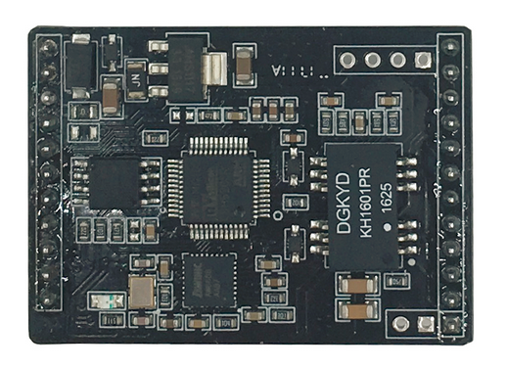 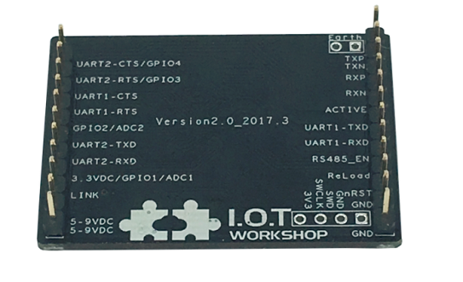

1. Eport-E30 Appearance

## Pins Definition

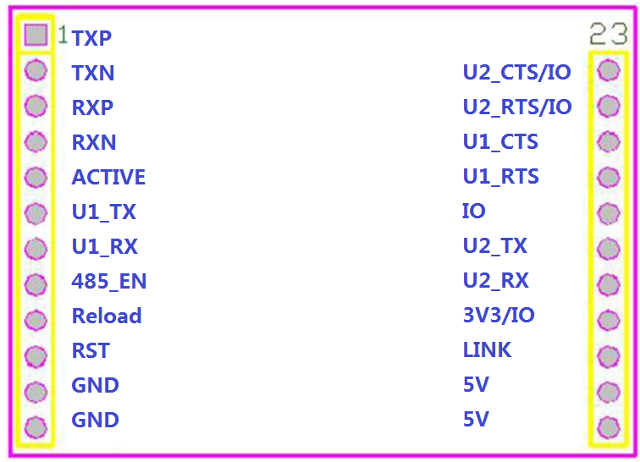

1. Eport-E30 Pins Map
2. Eport-E30 Pins Definition

| **Pin** | **Description** | **Net Name** | **Signal Type** | **Comments** |
| --- | --- | --- | --- | --- |
| 1 | Ethernet TX+ | TXP | O | TXP |
| 2 | Ethernet TX- | TXN | O | TXN |
| 3 | Ethernet RX+ | RXP | I | RXP |
| 4 | Ethernet RX- | RXN | I | RXN |
| 5 | LED_ACTIVE | ACTIVE | O | Low Active |
| 6 | UART1 | U1_TX | O | 3.3V TTL |
| 7 | UART1 | U1_RX | I | 3.3V TTL |
| 8 | 485_EN | 485_EN | I | Can be configured as 485 enable pin |
| 9 | nReload | nReload | I，PU | See following for details |
| 10 | Reset | nRST | I， PU | Hardware reset, low active |
| 11 | Ground | GND | GND |  |
| 12 | Ground | GND | GND |  |
| 13 | +5V Power | DVDD | Power | +5V~9V |
| 14 | +5V Power | DVDD | Power | +5V~9V |
| 15 | LED_LINK | LINK | O | Low Active |
| 16 | 3V3/IO | 3V3/IO |  | 3.3V Output  Or modify hardware to use it as GPIO |
| 17 | GPIO | U2_RX | I/O | UART2_RX  Debug UART(Reserved) |
| 18 | GPIO | U2_TX | I/O | UART2_TX  Debug UART(Reserved) |
| 19 | GPIO | IO | I/O | IO |
| 20 | UART1 | U1_RTS | I |  |
| 21 | UART1 | U1_CTS | O |  |
| 22 | UART2 | U2_RTS/IO | I/O |  |
| 23 | UART2 | U2_CTS/IO | I/O |  |

<Notes>

**nReload Pin function:**

1. After device is powered up, If put this pin to low more than 3 seconds and then put to High, It will restore the product parameters to factory setting.

We strongly suggest user to fan out this pin.

**ACTIVE Pin**

1. When there are data transmiting and receiving, This LED will flashing. If there is no data transmit and receive, It will output High.

**LINK Pin**

1. When Ethernet connected normal, It will output Low, If there is no Ethernet connection, It will output High.

## Electrical Characteristics

1. Absolute Maximum Ratings:

|  |  |  |  |  |  |
| --- | --- | --- | --- | --- | --- |
| **Parameter** | **Condition** | **Min.** | **Typ.** | **Max.** | **Unit** |
| Storage Temperature Range |  | -45 |  | 125 | °C |
| Maximum Soldering Temperature | IPC/JEDEC J-STD-020 |  |  | 260 | °C |
| Supply Voltage |  | 0 |  | 12 | V |
| ESD (Human Body Model HBM) | TAMB=25°C |  |  | 2 | KV |
| ESD (Charged Device Model, CDM) | TAMB=25°C |  |  | 1 | KV |

1. Power Supply & Power Consumption:

|  |  |  |  |  |  |
| --- | --- | --- | --- | --- | --- |
| **Parameter** | **Condition** | **Min.** | **Typ.** | **Max.** | **Unit** |
| Operating Supply Voltage |  |  | 5 | 9 | V |
| Operating Temperature Range |  | -40 |  | 85 | °C |
| Supply Current (10BASE-T activity)@ 96MHz | Without date transmit and receive |  | 40 |  | mA |
| Supply Current (100BASE-T activity)@ 96MHz | 5KB/S data |  | 140 |  | mA |
| Input Leakage Current | Ii | -10 |  | 10 | uA |
| Output high voltage | @IOH=2mA | 2.8 |  |  | V |
| Output Low Voltage | @IOL=2mA |  |  | 0.3 | V |
| Input High Voltage |  | 1.6 |  | 3.6 | V |
| Input Low Voltage |  | -0.3 |  | 1.4 | V |
| GPIO Input pull-up resistor |  |  | 200 |  | kΩ |
| GPIO Input pull-down resistor |  |  | 200 |  | kΩ |

## Ethernet Interface

The 10/100 Ethernet magnetics, network status LEDs, and RJ45 connector are all integrated into the Eport-E30 unit.

1. Ethernet Interface Definition

| **Pin** | **Description** | **Net Name** | **Signal Type** |
| --- | --- | --- | --- |
| 1 | Transmit Data + | TX+ | O |
| 2 | Transmit Data - | TX- | O |
| 3 | Receive Data + | RX+ | I |
| 4 | Receive Data - | RX- | I |
| 15 | LED_Link | LINK | O |

## Mechanical Size

The dimensions of Eport-E30 are defined as following picture (mm):

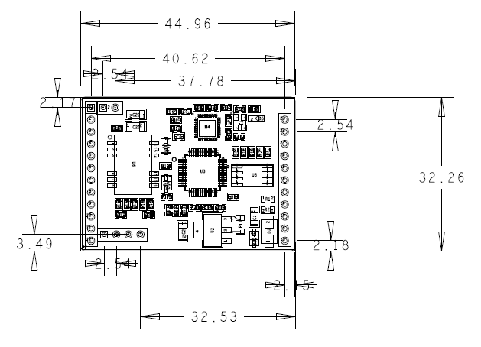

1. Eport-E30 Mechanical Dimension

## Order Information

Base on customer detailed requirement, Eport-E30 provide different configuration version, Details as below:

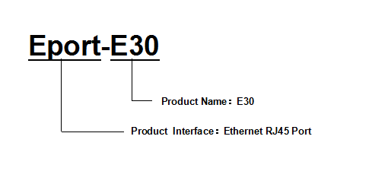

1. Eport-E30 Product Number Defination

## Function

See Eport-E10 manual for detailed usage. This module hardware and software soluction is the same as E10.