**Eport-E10**

**Super Port User Manual**

**V 1.4**

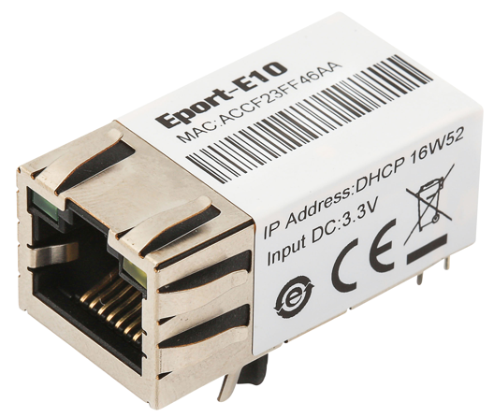

**Overview of Characteristic**

* **Cortex-M3 MCU with 2MB Flash and 128KB SRAM**
* **Use FreeRTOS Operation System**
* **Support TCP/IP/Telnet /Modbus TCP Protocol**
* **Support Serial To 10/100M Ethernet Conversion, Serial Speed Upto 921600 bps**
* **Support 10/100M Ethernet Auto-Negotiation**
* **Support Easy Configuration Through a Web Interface**
* **Support Security Protocol Such As** **TLS/AES/DES3**
* **Support Web OTA Wirelss Upgrade**
* **Support Industrial Temperature: -40 to +85˚ C**
* **Single +3.3V Power Supply**
* **Size: 33 x 18.6 x 15 mm (L x W x H)**
* **FCC/CE/RoHS Certificated**

# Table Of Contents Table Of Contents

Table Of Contents Table Of Contents 2

List Of Figures 3

List Of Tables 4

History 4

1. Product Overview 5

1.1. General Description 5

1.2. Device Features 5

1.3. Device Paremeters 6

1.4. Key Application 7

2. Hardware Introduction 8

2.1. Pins Definition 8

2.2. Electrical Characteristics 10

2.3. Ethernet Interface 10

2.4. Ethernet LED Interface 11

2.5. Mechanical Size 11

2.6. Recommended PCB Layout 11

2.7. Evaluation Kits 12

2.8. Order Information 13

2.9. Typical Application 13

Appendix a: Contact Information 15

List Of Figures

Figure 1. Eport-E10 Appearance 8

Figure 2. Eport-E10 Pins Map 8

Figure 3. Eport-E10 Mechanical Dimension 11

Figure 4. Eport-E10 PCB Layout 11

Figure 5. Eport-E10 EVK 12

Figure 6. Eport-E10 Product Number Defination 13

Figure 7. Eport-E10 Hardware Typical Application 13

List Of Tables

Table1. Eport-E10 Module Technical Specifications 6

Table2. Eport-E10 Pins Definition 9

Table3. Absolute Maximum Ratings: 10

Table4. Power Supply & Power Consumption: 10

Table5. Ethernet Interface Definition 10

Table6. LED Interface Definition 11

Table7. Eport-E10 EVK Interface 12

History

**Ed. V1.2**  09-06-2016 Update product appearance. Add more description of AES/DES3 encryption..

**Ed. V1.3**  10-12-2016 Update shipping information. Update TLS encryption.(Firmware version 1.6)

**Ed. V1.4**  02-06-2017 Add auto-ip, heartbeat,ntp,UART fast config function(Firmware 1.07c Version)

# Product Overview

## General Description

The Eport-E10 is a fully self-contained small form-factor, most compact, integrated solution, which provide a serial interface to Ethernet connectivity to web enable any device. The Eport-E10 integrate TCP/IP controller, memory, 10/100M Ethernet transceiver, high-speed serial port within a compact RJ45 package and integrates a fully developed TCP/IP network stack and FreeRTOS OS.The Eport-E10 also includes an embedded web server used to remotely configure, monitor, or troubleshoot the attached device.

The Eport-E10 using highly integrated hardware and software platform,It has been optimized for all kinds of applications in the industrial control, smart grid , personal medical application and remote control that have lower data rates, and transmit or receive data on an infrequent basis. By simply adding an Eport-E10 unit to a product Design, device manufacturers can reduce their Design cycle and speed up Time-To-Market with very low risk.

The Eport-E10 integrates all serial to Ethernet functionality into a low-profile, 33 x 18.6 x 15mm standard RJ45 module package that can be easily mounted on main PCB with application specific circuits and even not change your original Design.

## Device Features

* Cortex-M3 MCU with 2MB Flash and 128KB SRAM
* Full Integrated RJ45 Solution
* Support FreeRTOS Operation System
* Support TCP/IP、UDP、DHCP、DNS、HTTP Server/Client、ARP、BOOTP、AutoIP、ICMP、Telnet、FTP、TFTP、uPNP、NTP、ModbusTCP Protocol
* Support Serial to 10/100M Ethernet Conversion, Serial Speed Upto 921600 bps
* Support 10/100M Ethernet Auto-Negotiation
* Support Easy Configuration Through a Web Interface
* Support Security Protocol Such As TLS/AES/DES3
* Support Web Wireless Upgrade
* Support Industrial Temperature: -40 to +85˚ C
* Single +3.3V Power Supply
* Size: 33 x 18.6 x 15mm (L x W x H)
* FCC/CE/RoHS Certificated

## Device Paremeters

1. Eport-E10 Module Technical Specifications

|  |  |
| --- | --- |
| **Item** | **Parameters** |
| **System Information** | |
| Processor/Frequency | Cortex-M3/96MHz |
| Flash/SDRAM | 2MB/128KB |
| Operating System | FreeRTOS |
| **Ethernet Port** | |
| Port Number | 1 RJ45 with LED |
| Interface Standard | 10/100 Base-T Auto-Negotiation |
| Protection | 2KV Isolation |
| Transformer | Integrated |
| Network Protocol | IP, TCP, UDP, DHCP, DNS, HTTP Server/Client, ARP, BOOTP, AutoIP, ICMP, Web socket, Telnet, FTP,TFTP, uPNP, NTP, Modbus TCP |
| Security Protocol | TLS AES 128Bit  DES3 |
| IPV6 Support | No |
| **Serial Port** | |
| Port Number | 1 + 1 debug |
| Interface Standard | 3.3V TTL: 2 wire（TX,RX） |
| Data Bits | 5,6,7,8 |
| Stop Bit | 1,2 |
| Check Bit | None,Even,Odd,Space,Mark |
| Baud Rate | TTL: 600 bps~921600 bps |
| Flow Control | No Flow control  Hardware RTS/CTS、DSR/DTR  Software Xon/ Xoff flow control |
| **Software** | |
| Web Pages | Http Web Configuration  Customization of HTTP Web Pages |
| Configuration | Web  CLI  XML import  Telnet  IOTManager PC Software  UART Fast Config |
| Firmware Upgrade | Web or IOTManager |
| SDK For Dev. | Not yet |
| **Basic Parameter** | |
| Size | 33 x 18.6 x 15 mm |
| Operating Temp. | -45 ~ 85°C |
| Storage Temp. | -45 ~ 105°C, 5 ~ 95% RH（no condensation） |
| Input Voltage | 3.3V |
| Working Current | ~100mA |
| Power | <400mW |
| **Other Information** |  |
| Certificate | CE, FCC, RoHS |
| Material | Metal shell, thermoplastic case |

## Key Application

The Eport-E10 device connects serial device to Ethernet networks using the TCP/IP protocol:

* Remote equipment monitoring
* Asset tracking and telemetry
* Security Application
* Industrial sensors and controls
* Medical devices
* ATM machines
* Data collection devices
* Universal Power Supply (UPS) management units
* Telecommunications equipment
* Data display devices
* Handheld instruments
* Modems
* Time/attendance clocks and terminals

# Hardware Introduction

The Eport-E10 unit is a complete solution for serial port device connecting to network. Packageed into a RJ45 connector, this powerful device supports a 10/100BASE-T Ethernet connection, a reliable and proven operating system stored in flash memory, an embedded web server, a full TCP/IP protocol stack,and standards-based (AES) encryption.

Through Ethernet cable connect router with Eport –E10 serial server for data transfer, which makes the electromechanical integration very simple. Eport-E10 meet EMC Class B security level,It can pass every countries relevant certification test

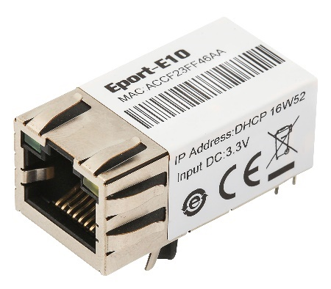 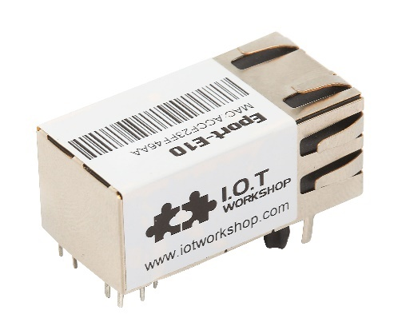

1. Eport-E10 Appearance

## Pins Definition

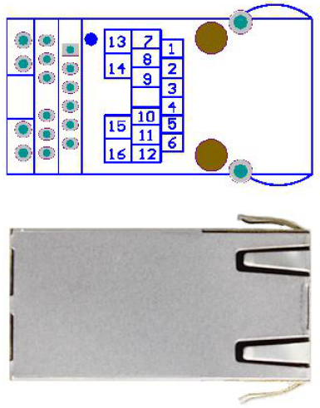 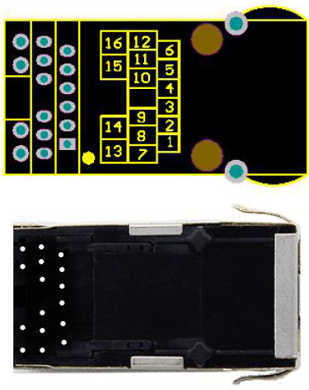

1. Eport-E10 Pins Map
2. Eport-E10 Pins Definition

| **Pin** | **Describtion** | **Net Name** | **Signal Type** | **Comments** |
| --- | --- | --- | --- | --- |
| 1 | GPIO | GPIO1 | I/O | Can be configured to UART1:TXD2 |
| 2 | GPIO | GPIO2 | I/O | Can be configured to UART1:RXD2 |
| 3 | UART0 | CTS | I | Can be configured to GPIO3 Pin |
| 4 | External Reset In | nRST | I, PU | “Low” effective reset input. |
| 5 | UART0 | RTS | O | Can be configured as RS485 control function |
| 6 | Multi-Function Pin | nReload | I,PU | Detailed functions see <Notes> |
| 7 | LED indicator | LED2_Data | O | If use product’s LED, must connect this Pin to Pin13,  If don’t use the product’s LED, may connect this Pin to external LED circuit.  Detailed functions see <Notes> |
| 8 | UART0 | RXD | I | 3.3V, TTL. |
| 9 | UART0 | TXD | O | 3.3V, TTL. |
| 10 | Ground | GND | GND | Power Ground |
| 11 | +3.3V Power | DVDD | Power | +3.3V |
| 12 | LED indicator | LED1_Link | O | If use product’s LED, must connect to Pin16.  If don’t use the product’s LED, may connect this Pin to external LED circuit.  Detailed functions see <Notes> |
| 13 | LED indicator | LED2 | I | If use product’s LED, connect to Pin7. If not use the product’s LED, leave it unconnected. |
| 14 | LED power | LED_3V3 | Power | LED_Data Power 3.3V, If don’t use the product’s LED, leave it unconnected. |
| 15 | LED power | LED_3V3 | Power | LED_Link Power 3.3V, If don’t use the product’s LED, leave it unconnected. |
| 16 | LED indicator | LED1 | I | If use product’s LED, connect to Pin12. If don’t use the product’s LED, leave it unconnected. |

<Notes>

**nReload Pin function:**

1. Put this pin low before the device powered on (or Reset), This device works in mass production mode to upgrade its firmware, this mode is used for upgrade customized firmware. The corresponding PC tools can be download on High Flying website.
2. After device is powered up, If put this pin to low more than 3 seconds and then put to High, It will restore the product parameters to factory setting.

We strongly suggest user to fan out this pin.

**LED2_Data Pin**

1. When there are data transmiting and receiving, This LED will flashing. If there is no data transmit and receive, It will output High.

**LED1_Link Pin**

1. When Ethernet connected normal, It will output Low, If there is no Ethernet connection, It will output High.

## Electrical Characteristics

1. Absolute Maximum Ratings:

|  |  |  |  |  |  |
| --- | --- | --- | --- | --- | --- |
| **Parameter** | **Condition** | **Min.** | **Typ.** | **Max.** | **Unit** |
| Storage Temperature Range |  | -45 |  | 125 | °C |
| Maximum Soldering Temperature | IPC/JEDEC J-STD-020 |  |  | 260 | °C |
| Supply Voltage |  | 0 |  | 3.8 | V |
| Voltage on any I/O pin |  | 0 |  | 3.3 | V |
| ESD (Human Body Model HBM) | TAMB=25°C |  |  | 2 | KV |
| ESD (Charged Device Model, CDM) | TAMB=25°C |  |  | 1 | KV |

1. Power Supply & Power Consumption:

|  |  |  |  |  |  |
| --- | --- | --- | --- | --- | --- |
| **Parameter** | **Condition** | **Min.** | **Typ.** | **Max.** | **Unit** |
| Operating Supply Voltage |  | 3.0 | 3.3 | 3.6 | V |
| Operating Temperature Range |  | -45 |  | 85 | °C |
| Supply Current (10BASE-T activity)@ 96MHz | Without date transmit and receive |  | 40 |  | mA |
| Supply Current (100BASE-T activity)@ 96MHz | 5KB/S data |  | 140 |  | mA |
| Input Leakage Current | Ii | -10 |  | 10 | uA |
| Output high voltage | @IOH=2mA | 2.8 |  |  | V |
| Output Low Voltage | @IOL=2mA |  |  | 0.3 | V |
| Input High Voltage |  | 1.6 |  | 3.6 | V |
| Input Low Voltage |  | -0.3 |  | 1.4 | V |
| GPIO Input pull-up resistor |  |  | 200 |  | kΩ |
| GPIO Input pull-down resistor |  |  | 200 |  | kΩ |

## Ethernet Interface

The 10/100 Ethernet magnetics, network status LEDs, and RJ45 connector are all integrated into the Eport-E10 unit.

1. Ethernet Interface Definition

| **Pin** | **DES3cribtion** | **Net Name** | **Signal Type** |
| --- | --- | --- | --- |
| 1 | Transmit Data + | TX+ | O |
| 2 | Transmit Data - | TX- | O |
| 3 | Receive Data + | RX+ | I |
| 4 | NC |  |  |
| 5 | NC |  |  |
| 6 | Receive Data - | RX- | I |
| 7 | NC |  |  |
| 8 | NC |  |  |
| 9 | Case Ground | SHIELD |  |

## Ethernet LED Interface

The device contains two bi-color Ethernet LED indicator (Detailed postion is in dimension drawing .)

1. LED Interface Definition

| **Link LED (Left Side)** | | **Activity LED (Right Side)** | |
| --- | --- | --- | --- |
| Color | Meaning | Color | Meaning |
| Off | No Connection | Off | No Data |
| Green | 10/100Mbps | Yellow | Have Data |

## Mechanical Size

The dimensions of Eport-E10 are defined as following picture (mm):

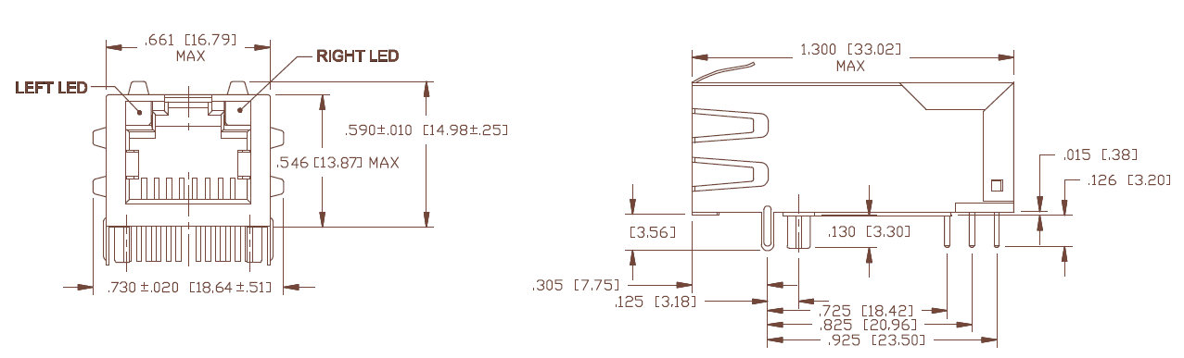

1. Eport-E10 Mechanical Dimension

## Recommended PCB Layout

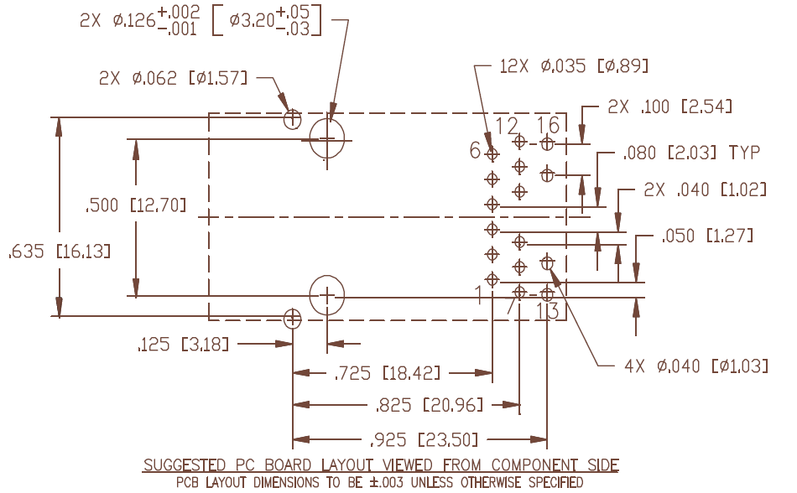

1. Eport-E10 PCB Layout

PCBA should have approximately 2.54cm x 2.54cm large plane GND to connect with product GND for heat dissipation, The device’s metal shell is also a important way of heat dissipation.

## Evaluation Kits

We provide evaluation kit for user to learn to use Eport-E10. Evaluation kit picture is as following, User can use RS232, USB Serial or Ethernet interface to configure parameters, manage equipment and do some function test. ( onboard FT232R chip switch, its driver can be download from high flying website, When using USB Serial, the top right corner jumper need to all jump to the left side). .

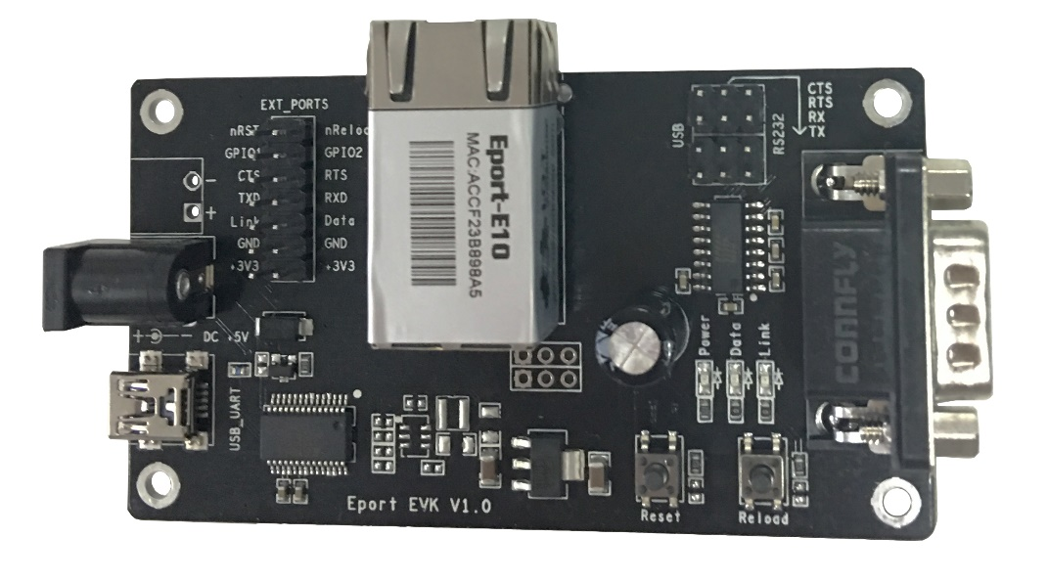

1. Eport-E10 EVK

Evaluation kit interface details as following:

1. Eport-E10 EVK Interface

| **Function** | **Name** | **Describe** |
| --- | --- | --- |
| **External Interface** | COM | Main data/command RS-232 interface |
| USB_UART | UART to USB debug interface（Used for PC debug envirement which without RS232 interface, Need load drivers to use）, Can be power supply port |
| DC5 | DC 5V input |
| EXT PORT | GPIO Pin interface |
| JMP | 4Pin USB or RS232 jumper.  All jump to left choose USB Serial..  All jump to right choose RS232 |
| **LED** | Power | 3.3V Power Indicate |
| Link | Network indicator, **Detailed functions see** LED1_Link Pin**<Notes**> |
| Data | Communication indicator,  **Detailed functions see** LED2_Data Pin**<Notes**> |
| **Button** | Reset | “Reset” Button |
| Reload | Press down the button more than 3s and then loose to restore factory setting |

## Order Information

Base on customer detailed requirement, Eport-E10 provide different configuration version, Details as below:

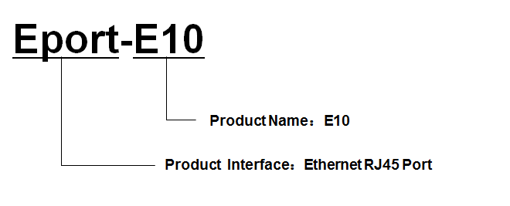

1. Eport-E10 Product Number Defination

## Typical Application

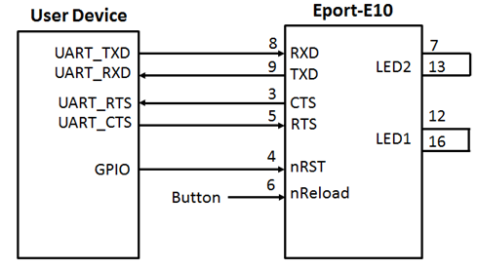

1. Eport-E10 Hardware Typical Application

**Notes:**

**nRST-** Input.Hardware reset signal. Effective Low.

There is internal pull-up resistor to 3.3V and no external pull-up resistor needed. MCU put nRST signal to low for at least 10ms if need to reset the device.

**nReload**- Input.Device restore to factory default configuration. Effective Low; **（Recommend this pin to connect button or jumper header, Used for batch upgrade and configuration）**

Can connect with external button or chip pin, When press nReload button, pull the pin to Low level more than 3s, then loose, device will restore to factory default setting and restart itself. If nReload function is not required, Can leave this pin open, Don’t need any connection.

**TXD/RXD**- UART port data transmit and receive signal.

# 

# Appendix a: Contact Information

**------------------------------------------------------------------------------------------------------------**

**Address:** Room 1002,Building 1,No.3000,Longdong Avenue,Pudong New Area,Shanghai,China,201203

**Web:** [www.iotworkshop.com](http://www.iotworkshop.com) or [www.hi-flying.com](http://www.hi-flying.com)

**Contact:**

Sales: [sales@iotworkshop.com](mailto://sales@iotworkshop.com)

Support: [support@iotworkshop.com](mailto://support@iotworkshop.com)

Service: [service@iotworkshop.com](mailto://service@iotworkshop.com)

Business: [business@iotworkshop.com](mailto://business@iotworkshop.com)

**---------------------------------------------------------------------------- -------------------------------**

For more information about IOTworkshop modules, applications, and solutions, please visit our web site www.iotworkshop.com

**<END OF DOCUMENT>**