**Eport Pro-EP40**

**Linux Ethernet Module**

**User Manual**

**V 1.0**

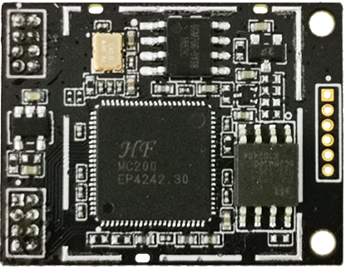

**Overview of Characteristic**

* **MIPS MCU(32MB SRAM) with 16MB Flash**
* **Use Linux Operation System**
* **Support TCP/IP/Telnet/Modbus TCP Protocol**
* **Support Serial To 10/100M Ethernet Conversion, Serial Speed Upto 460800 bps**
* **Support 10/100M Ethernet Auto-Negotiation**
* **Support Easy Configuration Through a Web Interface**
* **Support Security Protocol Such As** **TLS/AES/DES3**
* **Support Web OTA Wirelss Upgrade**
* **Single +3.3V Power Supply**
* **Size: 29mm x 22.5mm x 2.7mm**

# Table Of Contents Table Of Contents

Table Of Contents Table Of Contents 3

List Of Figures 4

List Of Tables 5

History 5

1. Product Overview 6

1.1. General Description 6

1.2. Device Paremeters 6

1.3. Key Application 7

2. Hardware Introduction 8

2.1. Appearance 8

2.2. Pins Definition 9

2.3. Electrical Characteristics 10

2.4. Eport Pro-EP40 Mechanical Size 11

2.5. Order Information 11

2.6. Typical Application 12

2.7. Software Function 13

Appendix A: HW Reference Design 14

Appendix B: Contact Information 15

List Of Figures

Figure 1. Eport Pro-EP40 Appearance 8

Figure 2. Eport Pro-EP40 Pins Map 9

Figure 3. Eport Pro-EP40 Mechanical Dimension 11

Figure 4. Eport Pro-EP40 Product Number Defination 12

Figure 5. Eport Pro-EP40 Hardware Typical Application 12

Figure 6. HW REFERENCE DESIGN 14

List Of Tables

Table1. Eport Pro-EP40 Module Technical Specifications 6

Table2. Eport Pro-EP40 Pins Definition 9

Table3. Absolute Maximum Ratings: 10

Table4. Power Supply & Power Consumption: 10

History

**Ed. V1.0**  07-01-2019 First Version

# Product Overview

## General Description

The Eport Pro-EP40 is a fully self-contained small form-factor, most compact, integrated solution, which provide a serial interface to Ethernet connectivity to web enable any device. The Eport Pro-EP40 integrate TCP/IP controller, memory, 10/100M Ethernet PHY, high-speed serial port within a compact RJ45 package and integrates a fully developed TCP/IP network stack and Linux OS. The Eport Pro-EP40 Series also includes an embedded web server used to remotely configure, monitor, or troubleshoot the attached device. Need external transformer and RJ45 interface for usage.

## Device Paremeters

1. Eport Pro-EP40 Module Technical Specifications

|  |  |
| --- | --- |
| **Item** | **Parameters** |
| **System Information** | |
| Processor/Frequency | MIPS/320MHz |
| Flash/SDRAM | 16MB/32MB |
| Operating System | Linux |
| **Ethernet Port** | |
| Port Number | Ethernet PHY |
| Interface Standard | 10/100 Base-T Auto-Negotiation |
| Protection | 2KV Isolation |
| Transformer | Integrated |
| Network Protocol | IP，TCP，UDP，DHCP，DNS，HTTP Server/Client，ARP, BOOTP, AutoIP, ICMP，Web socket, Telnet, uPNP, NTP,Modbus TCP |
| Security Protocol | TLS v1.2  AES 128Bit  DES3 |
| **Serial Port** | |
| Port Number | 1 |
| Interface Standard | 3.3V TTL: 2 wire（TX,RX） |
| Data Bits | 8 |
| Stop Bit | 1,2 |
| Check Bit | None,Even,Odd |
| Baud Rate | TTL: 600 bps~460800 bps |
| Flow Control | No Flow control  Hardware RTS/CTS、DSR/DTR  Software Xon/ Xoff flow control |
| **Software** | |
| Web Pages | Http Web Configuration  Customization of HTTP Web Pages |
| Log | Remote Realtime Log, |
| Configuration | Web  CLI  XML import  Telnet  IOTService PC Software  UART Fast Config |
| Firmware Upgrade | Web, IOTService |
| **Basic Parameter** | |
| Size | 29mm x 22.5mm x 2.7mm |
| Operating Temp. | -25 ~ 70°C |
| Storage Temp. | -45 ~ 105°C, 5 ~ 95% RH（no condensation） |
| Input Voltage | 3.3V |
| Working Current | ~100mA |
| Power | <400mW |

## Key Application

The Eport Pro-EP40 Module connects serial device to Ethernet networks using the TCP/IP protocol:

* Remote equipment monitoring
* Asset tracking and telemetry
* Security Application
* Industrial sensors and controls
* Medical devices
* ATM machines
* Data collection devices
* Universal Power Supply (UPS) management units
* Telecommunications equipment
* Data display devices
* Handheld instruments
* Modems
* Time/attendance clocks and terminals

# Hardware Introduction

Through Ethernet cable connect router with Eport Pro–EP40 for data transfer, which makes the electromechanical integration very simple. Eport Pro-EP40 meet EMC Class B security level. It can pass every countries relevant certification test

## Appearance

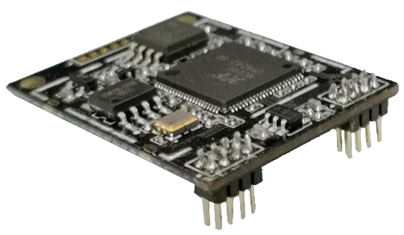 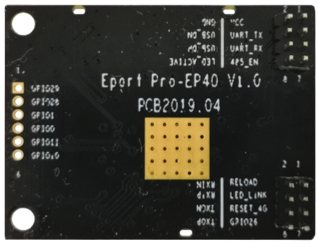

1. Eport Pro-EP40 Appearance

## Pins Definition

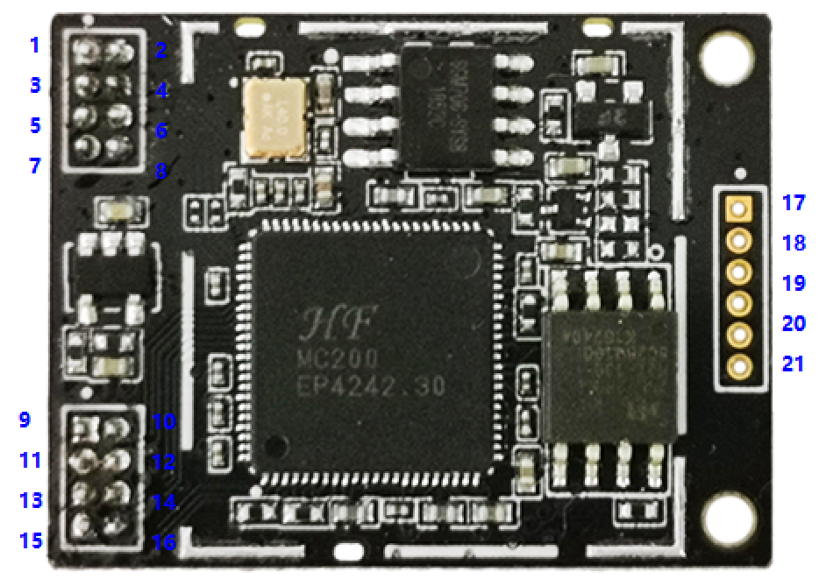

1. Eport Pro-EP40 Pins Map
2. Eport Pro-EP40 Pins Definition

| **Pin** | **Description** | **Net Name** | **Signal Type** | **Comments** |
| --- | --- | --- | --- | --- |
| 1 | +3.3V Power | DVDD | Power | +3.3V |
| 2 | Ground | GND | GND | Power Ground |
| 3 | UART0 | TXD | O | 3.3V, TTL. |
| 4 | USB_DM | USB_DM | I/O |  |
| 5 | UART0 | RXD | I | 3.3V, TTL. |
| 6 | USB_DP | USB_DP | I/O |  |
| 7 | GPIO03 | GPIO03 | I/O |  |
| 8 | LED indicator | LED2_Data | O | Detailed functions see <Notes> |
| 9 | Multi-Function Pin | nReload | I,PU | Detailed functions see <Notes> |
| 10 | Ethernet Interface | PHY_RX- | I | Ethernet Interface  Need connect to network transformer |
| 11 | LED indicator | LED1_Link | O | Detailed functions see <Notes> |
| 12 | Ethernet Interface | PHY_RX+ | I | Ethernet Interface  Need connect to network transformer |
| 13 | GPIO27 | GPIO27 | I/O |  |
| 14 | Ethernet Interface | PHY_TX- | O | Ethernet Interface  Need connect to network transformer |
| 15 | GPIO26 | GPIO26 | I/O |  |
| 16 | Ethernet Interface | PHY_TX+ | O | Ethernet Interface  Need connect to network transformer |
| 17 | GPIO29 | GPIO29 | I/O | Reserved |
| 18 | GPIO28 | GPIO28 | I/O |
| 19 | GPIO01 | GPIO01 | I/O |
| 20 | GPIO11 | GPIO11 | I/O |
| 21 | GPIO10 | GPIO10 | I/O |

<Notes>

**nReload Pin function:**

1. Put this pin low before the device powered on (or Reset), This device works in mass production mode to upgrade its firmware, this mode is used for upgrade customized firmware. The corresponding PC tools can be download on High Flying website.
2. After device is powered up, If put this pin to low more than 3 seconds and then put to High, It will restore the product parameters to factory setting.

We strongly suggest user to fan out this pin.

**LED2_Data Pin**

1. When there are data transmiting and receiving, This LED will flashing. If there is no data transmit and receive, It will output High.

**LED1_Link Pin**

1. When Ethernet connected normal, It will output Low, If there is no Ethernet connection, It will output High.

## Electrical Characteristics

1. Absolute Maximum Ratings:

|  |  |  |  |  |  |
| --- | --- | --- | --- | --- | --- |
| **Parameter** | **Condition** | **Min.** | **Typ.** | **Max.** | **Unit** |
| Storage Temperature Range |  | -45 |  | 125 | °C |
| Maximum Soldering Temperature | IPC/JEDEC J-STD-020 |  |  | 260 | °C |
| Supply Voltage |  | 0 |  | 3.8 | V |
| Voltage on any I/O pin |  | 0 |  | 3.3 | V |
| ESD (Human Body Model HBM) | TAMB=25°C |  |  | 2 | KV |
| ESD (Charged Device Model, CDM) | TAMB=25°C |  |  | 1 | KV |

1. Power Supply & Power Consumption:

|  |  |  |  |  |  |
| --- | --- | --- | --- | --- | --- |
| **Parameter** | **Condition** | **Min.** | **Typ.** | **Max.** | **Unit** |
| Operating Supply Voltage |  | 3.1 | 3.3 | 3.6 | V |
| Operating Temperature Range |  | -25 |  | 70 | °C |
| Supply Current (10BASE-T activity)@ 96MHz | Without date transmit and receive |  | 150 |  | mA |
| Supply Current (100BASE-T activity)@ 96MHz | 5KB/S data |  | 200 |  | mA |
| Input Leakage Current | Ii | -10 |  | 10 | uA |
| Output high voltage | @IOH=2mA | 2.8 |  |  | V |
| Output Low Voltage | @IOL=2mA |  |  | 0.3 | V |
| Input High Voltage |  | 1.6 |  | 3.6 | V |
| Input Low Voltage |  | -0.3 |  | 1.4 | V |
| GPIO Input pull-up resistor |  |  | 200 |  | kΩ |
| GPIO Input pull-down resistor |  |  | 200 |  | kΩ |

## Eport Pro-EP40 Mechanical Size

The dimensions of Eport Pro-EP40 are defined as following picture (mm):

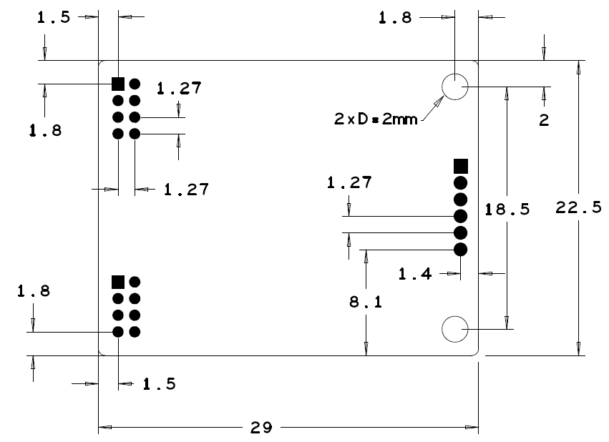

1. Eport Pro-EP40 Mechanical Dimension

## Order Information

Base on customer detailed requirement, Eport Pro-EP40 provide different configuration version, Details as below:

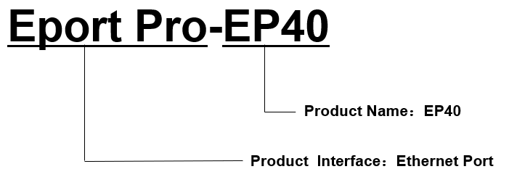

1. Eport Pro-EP40 Product Number Defination

## Typical Application

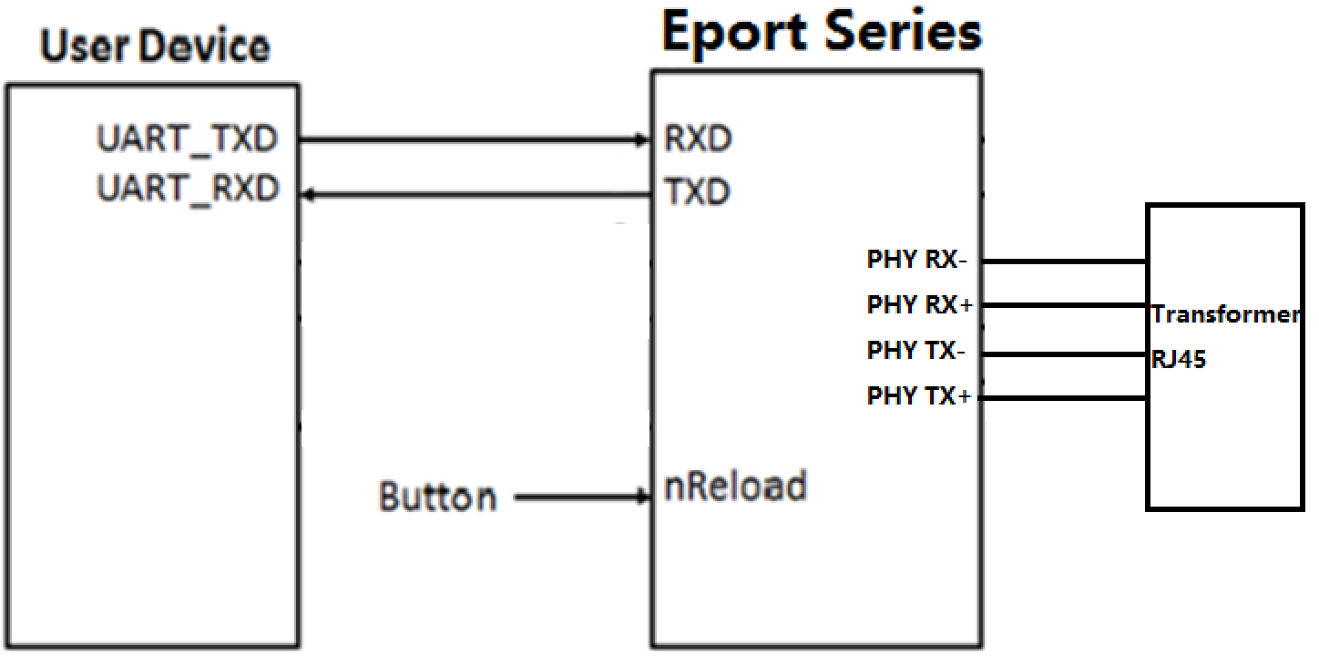

1. Eport Pro-EP40 Hardware Typical Application

**Notes:**

**nRST-** Input.Hardware reset signal. Effective Low.

There is internal pull-up resistor to 3.3V and no external pull-up resistor needed. MCU put nRST signal to low for at least 10ms if need to reset the device.

**nReload**- Input.Device restore to factory default configuration. Effective Low; **（Recommend this pin to connect button or jumper header, Used for batch upgrade and configuration）**

Can connect with external button or chip pin, When press nReload button, pull the pin to Low level more than 3s, then loose, device will restore to factory default setting and restart itself. If nReload function is not required, Can leave this pin open, Don’t need any connection.

**TXD/RXD**- UART port data transmit and receive signal.

## Software Function

Refer to “IOT_Device_Series_Software_Funtion” document for detailed usage.

# Appendix A: HW Reference Design

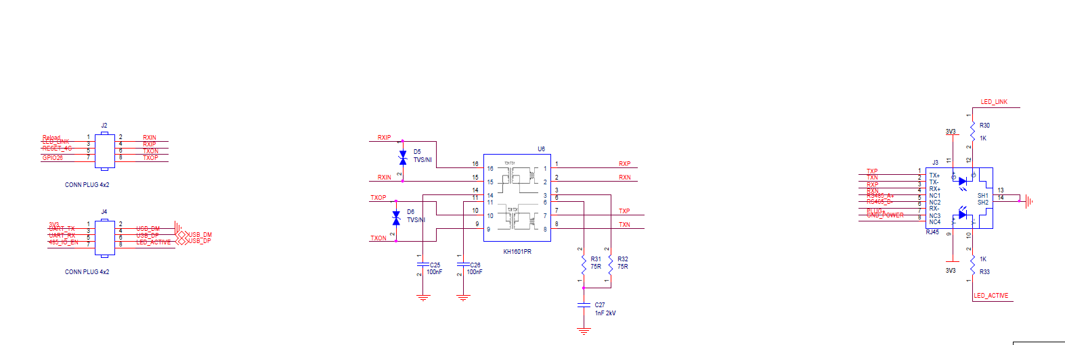

1. HW REFERENCE DESIGN

# 

# Appendix B: Contact Information

**------------------------------------------------------------------------------------------------------------**

**Address:** Room 1002,Building 1,No.3000,Longdong Avenue,Pudong New Area,Shanghai,China,201203

**Web:** [www.iotworkshop.com](http://www.iotworkshop.com) or [www.hi-flying.com](http://www.hi-flying.com)

**Contact:**

Sales: [sales@iotworkshop.com](mailto://sales@iotworkshop.com)

Support: [support@iotworkshop.com](mailto://support@iotworkshop.com)

Service: [service@iotworkshop.com](mailto://service@iotworkshop.com)

Business: [business@iotworkshop.com](mailto://business@iotworkshop.com)

**---------------------------------------------------------------------------- -------------------------------**

For more information about IOTworkshop modules, applications, and solutions, please visit our web site www.iotworkshop.com

**<END OF DOCUMENT>**