**Elfin-EE21**

**RS485 to Ethernet**

**User Manual**

**V 1.0**

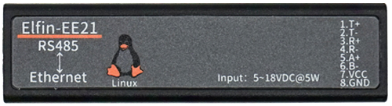

**Overview of Characteristic**

* **Use MIPS MCU (32MB SRAM) and 16MB Flash, based on Linux OS**
* **Support TCP/IP/Telnet /Modbus TCP Protocol**
* **Support RS485 To 10/100M Ethernet Conversion, Serial Speed Up to 460800 bps**
* **Support 10/100M Ethernet Auto-Negotiation**
* **Support Webpage Easy Configuration or PC IOTService Tool**
* **Support Security Protocol Such As** **TLS/AES/DES3**
* **Support Heartbeat and Resister Packet Function**
* **Support Webpage OTA Wireless Upgrade**
* **Wide DC Input 5~18VDC**
* **Size: 61 x 26 x 17.8 mm (L x W x H)**

# Table Of Contents Table Of Contents

Table Of Contents Table Of Contents 2

List Of Figures 3

List Of Tables 4

History 4

1. Product Overview 5

1.1. General Description 5

1.2. Device Paremeters 5

1.3. Key Application 6

2. Hardware Introduction 7

2.1. Elfin-EE21 Pins Definition 7

2.2. RS485 Interface 8

2.3. Mechanical Size 8

2.4. RJ45 8PIN Connector 9

2.5. EE21 Interface Conversion Cable 10

2.6. Fixed Bracket 10

2.7. Rail Bracket 11

2.8. Bracket 11

2.9. Product Installation 12

2.10. EVK 12

2.11. Order Information 13

Appendix A: Contact Information 14

List Of Figures

Figure 1. Elfin-EE21 Appearance 7

Figure 2. Elfin-EE21 RJ45 Interface Pin 7

Figure 3. Elfin-EE21 Mechanical Dimension 9

Figure 4. RJ45 8PIN Connector 9

Figure 5. EE21+8PIN Connector 9

Figure 6. Interface Conversion Cable 10

Figure 7. Fixed Bracket 10

Figure 8. Rail Bracket 11

Figure 9. Bracket Size 11

Figure 10. Bracket Install Picture 12

Figure 11. Product Installation 12

Figure 12. EVK Package 13

Figure 13. Elfin-EE21 Product Order Information 13

List Of Tables

Table1. Elfin-EE21 Technical Specifications 5

Table2. Elfin-EE21 Interface Definition 7

History

**Ed. V1.0**  07-02-2019 First Version

# Product Overview

## General Description

The Elfin-EE21 provides a RS485 interface to Ethernet connectivity to web enable any device. The Elfin-EE21 integrate TCP/IP controller, memory, 10/100M Ethernet transceiver, high-speed serial port and integrates a fully developed TCP/IP network stack and Linux OS. Elfin-EE21 also includes an embedded web server used to remotely configure, monitor, or troubleshoot the attached device.

The Elfin-EE21 using highly integrated hardware and software platform, it has been optimized for all kinds of applications in the industrial control, smart grid, personal medical application and remote control that have lower data rates, and transmit or receive data on an infrequent basis.

The Elfin-EE21 integrates all serial to Ethernet functionality with 61 x 26 x 17.8mm size.

## Device Paremeters

1. Elfin-EE21 Technical Specifications

|  |  |
| --- | --- |
| **Item** | **Parameters** |
| **System Information** | |
| Processor/Frequency | 320MHz |
| Flash/SDRAM | 16MB/32MB |
| Operating System | OpenWRT Linux |
| **Ethernet Port** | |
| Port Number | 1 |
| Interface Standard | 10/100 Base-T Auto-Negotiation |
| Transformer | Integrated |
| Network Protocol | IP，TCP，UDP，DHCP，DNS，HTTP Server/Client，ARP, AutoIP, ICMP， Telnet, NTP, Modbus TCP |
| Security Protocol | TLS 1.2  AES 128Bit  DES3 |
| **Serial Port** | |
| Port Number | EE21: RS485 |
| Data Bits | 8 |
| Stop Bit | 1,2 |
| Check Bit | None, Even, Odd |
| Baud Rate | TTL: 600 bps~460800 bps |
| Flow Control | No Flow Control  Software Xon/ Xoff flow control |
| **Software** | |
| Web Pages | Http Web Configuration  Customization of HTTP Web Pages |
| Configuration | Web  CLI  XML import  Telnet  IOTService PC Software  UART Fast Config |
| Firmware Upgrade | Webpage, IOTService Tools |
| **Basic Parameter** | |
| Size | 61 x 26 x 17.8 mm |
| Operating Temp. | -25 ~ 70°C |
| Storage Temp. | -45 ~ 105°C, 5 ~ 95% RH（no condensation） |
| Input Voltage | 5~18VDC |
| Working Current | ~100mA |
| Power | <400mW |

## Key Application

The Elfin-EE21 device connects serial device to Ethernet networks using the TCP/IP protocol:

* Remote equipment monitoring
* Asset tracking and telemetry
* Security Application
* Industrial sensors and controls
* Medical devices
* ATM machines
* Data collection devices
* Universal Power Supply (UPS) management units
* Telecommunications equipment
* Data display devices
* Handheld instruments
* Modems
* Time/attendance clocks and terminals

# Hardware Introduction

The Elfin-EE21 unit is a complete solution for serial port device connecting to network. This powerful device supports a 10/100BASE-T Ethernet connection, a reliable and proven operating system stored in flash memory, an embedded web server, a full TCP/IP protocol stack, and standards-based (AES) encryption.

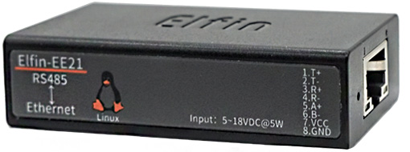

1. Elfin-EE21 Appearance

## Elfin-EE21 Pins Definition

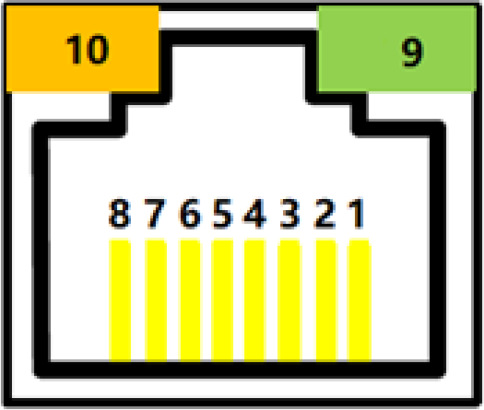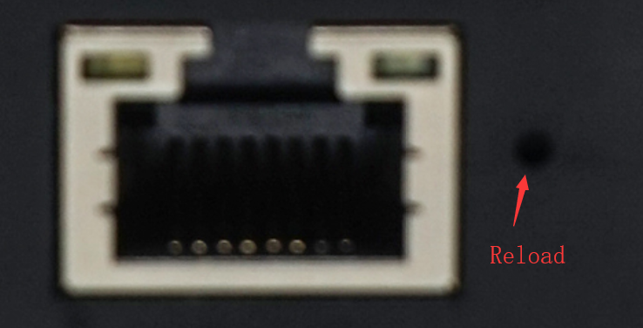

1. Elfin-EE21 RJ45 Interface Pin
2. Elfin-EE21 Interface Definition

| **Pin** | **Description** | **Net Name** | **Signal Type** | **Notes** |
| --- | --- | --- | --- | --- |
| 1 | Ethernet TX+ | TX+ | O | Connect to Standard Ethernet RJ45 PIN1 |
| 2 | Ethernet TX- | TX- | O | Connect to Standard Ethernet RJ45 PIN2 |
| 3 | Ethernet RX+ | RX+ | I | Connect to Standard Ethernet RJ45 PIN3 |
| 4 | Ethernet RX- | RX- | I | Connect to Standard Ethernet RJ45 PIN6 |
| 5 | RS485_A+ | RS485_A+ | IO |  |
| 6 | RS485_B- | RS485_B- | IO |  |
| 7 | Power VCC | VCC | Power | 9～18VDC@1A |
| 8 | Power GND | GND | Power |  |
| 9 | **Green LED**  Net Status | Net | O | On:Bootup OK.  0.3s Off -> 3s On: Ethernet connection is OK.  0.3s Off ->0.3s On: No Ethernet connection. |
| 10 | **Amber LED**  Data Transfer | Active | O | Off: No data transfer  0.3s Off -> 0.9s On: UART TX Output  0.3s Off -> 0.3s On: UART RX Receive  On: UART bidirection. |
|  | Restore to Factory | nReload | I | Default high. Long press this button ("Low">3s) and loose to make the module restore to factory setting. |

**<Notes>**

**I — Input; O — Output; I/O: Digital I/O; Power—Power Supply**

## RS485 Interface

RS485 use two wire links, A(DATA+), B(DATA-). Connect A(+) to A(+), B(-) to B(-) for communication. Suggest to connect GND together when interference is very severe.

The RS485 interface support maximum 32 RS485 device. The cable maximum length is 1200 meters. Need to add 120Ohm terminal resistor for over 300 meters.

## Mechanical Size

The dimensions of Elfin-EE21 are defined as following picture (mm):

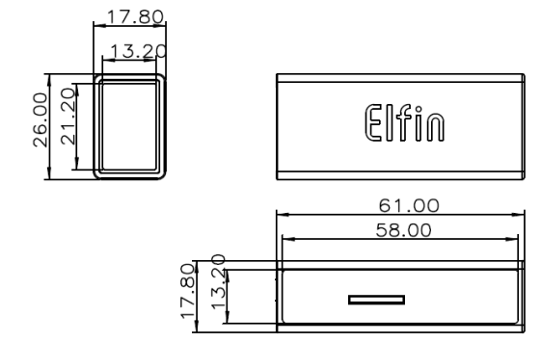

1. Elfin-EE21 Mechanical Dimension

## RJ45 8PIN Connector

RJ45 8PIN Connector Type Order: 10810001001

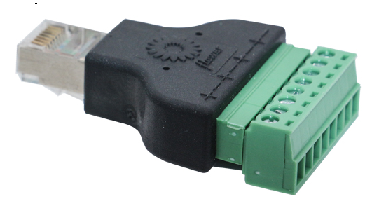

1. RJ45 8PIN Connector

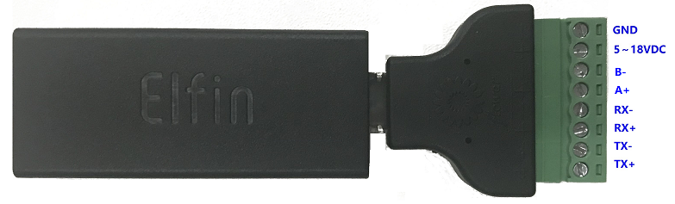

1. EE21+8PIN Connector

## EE21 Interface Conversion Cable

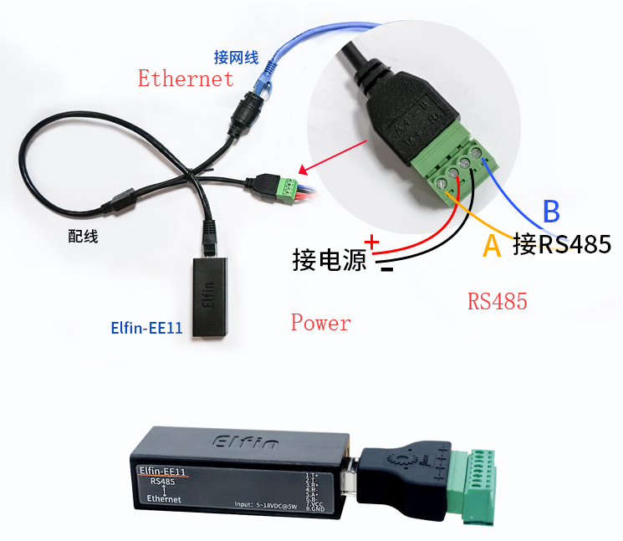

1. Interface Conversion Cable

## Fixed Bracket

Bracket Type Order: 10810003001

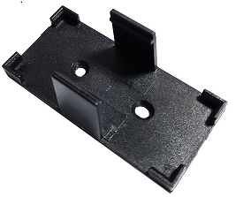

1. Fixed Bracket

## Rail Bracket

Bracket Type Order: 10703000003

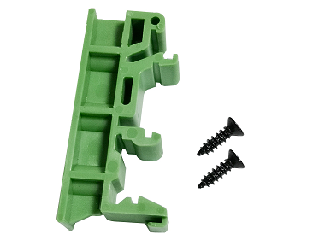

1. Rail Bracket

## Bracket

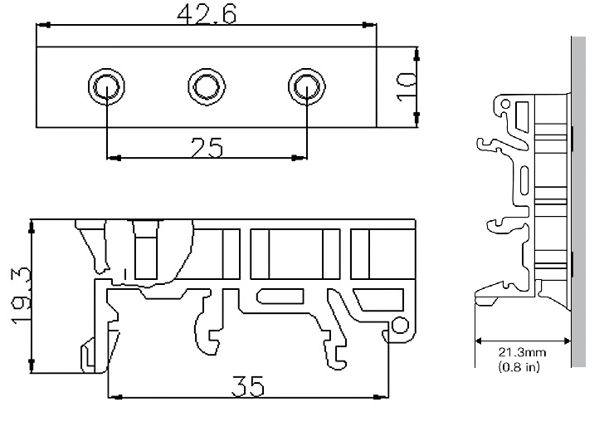

1. Bracket Size

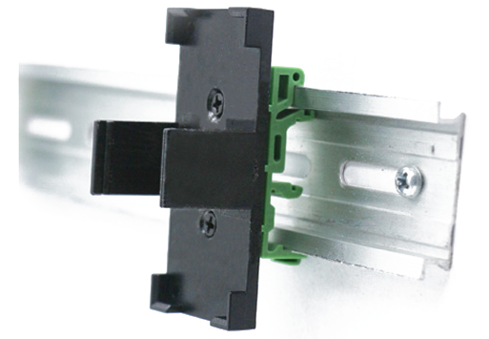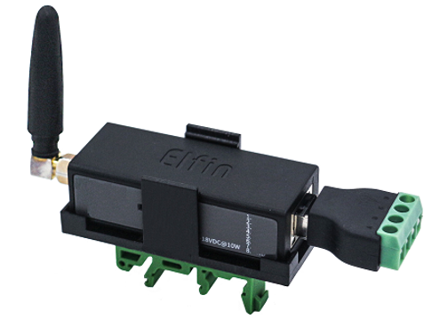

1. Bracket Install Picture

## Product Installation

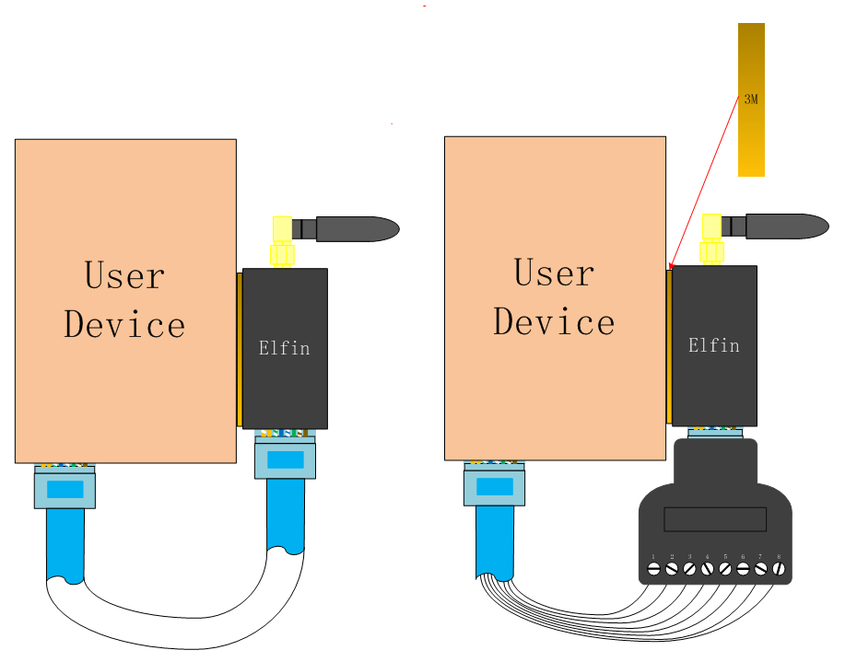

1. Product Installation

## EVK

EVK indluce one Elfin device, one RJ45 Connector and one screw driver.

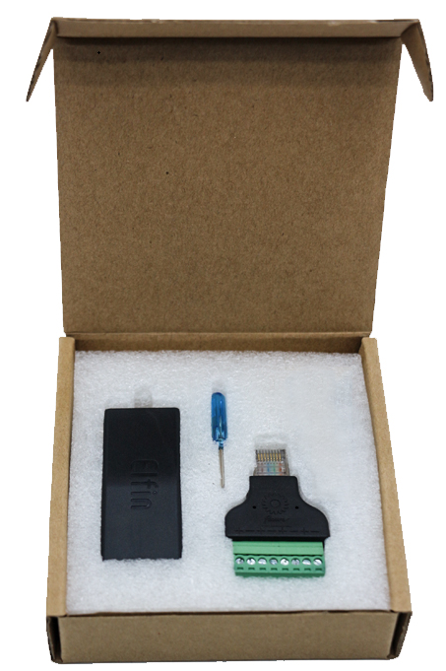

1. EVK Package

## Order Information

Base on customer detailed requirement, Elfin-EE21 provide different configuration version, Details as below:

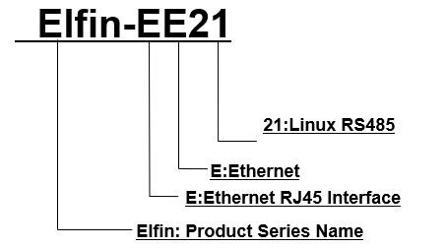

1. Elfin-EE21 Product Order Information

# Appendix A: Contact Information

**------------------------------------------------------------------------------------------------------------**

**Address:** Room 1002,Building 1,No.3000,Longdong Avenue,Pudong New Area,Shanghai,China,201203

**Web:** [www.iotworkshop.com](http://www.iotworkshop.com) or [www.hi-flying.com](http://www.hi-flying.com)

**Contact:**

Sales: [sales@iotworkshop.com](mailto://sales@iotworkshop.com)

Support: [support@iotworkshop.com](mailto://support@iotworkshop.com)

Service: [service@iotworkshop.com](mailto://service@iotworkshop.com)

Business: [business@iotworkshop.com](mailto://business@iotworkshop.com)

**---------------------------------------------------------------------------- -------------------------------**

For more information about IOTworkshop modules, applications, and solutions, please visit our web site www.iotworkshop.com

**<END OF DOCUMENT>**